Apple Pie
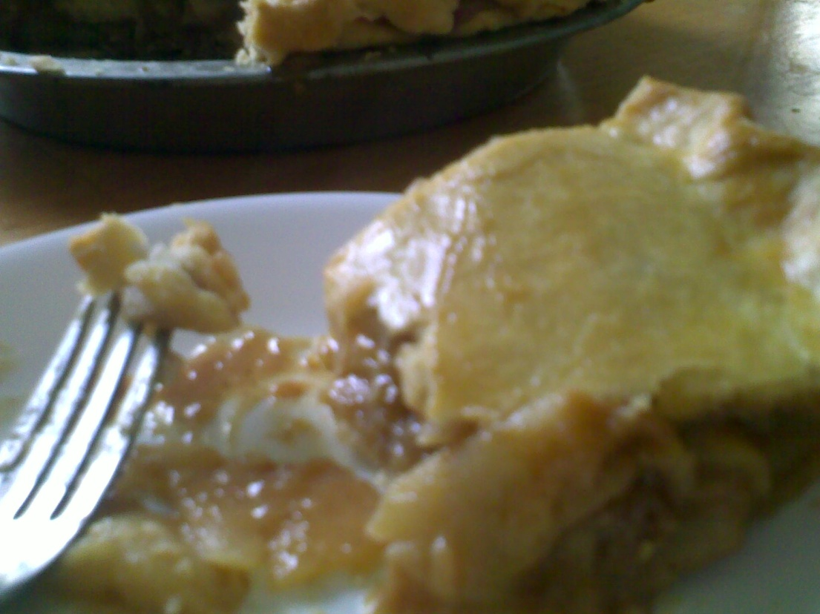
PIE CRUST:
All Purpose Flour 1 ¼ cups
Cake flour 1 cup
Baking powder ¼ teaspoon
Salt ½ teaspoon
Butter, unsalted ½ cup, cut into small cubes
Shortening ¼ cup, cut into small cubes then chilled back again with the butter
Ice chilled water 5-6 Tablespoons
YOU WILL NEED:
GREASED 9-INCH PIE PAN
CUT TWO PARCHMENT OR WAX PAPER LARGER THAN THE SIZE OF THE PAN, ABOUT TWO INCHES LARGER AROUND THE SIDES FOR THE BOTTOM CRUST, AND TWO MORE WAX PAPER FOR THE TOP CRUST.
CAKE FLOUR FOR DUSTING
ROLLING PIN

Procedure:
Combine the flour (all purpose and cake flour), baking powder and salt in a mixing bowl. Using two knives, a pastry blender or your fingers (must be dipped in cold water first), cut in chilled shortening and butter until mixture is uniform and resembles large peas. Don’t overblend.
Sprinkle with water, 1 tablespoon at a time, mixing lightly with a fork after each addition. Add just enough water to hold dough together. Press the dough between your palms and if they stick together and does not crumble and hold, add a bit more water. The crust should not be sticky.
Gather the dough into two disks, one larger than the other (top crust). Flatten and wrap in plastic, relax for at least an hour or so.
Roll the bottom crust first by placing the dough in between two sheets of plastic DUSTED WITH CAKE FLOUR, not cling wrap or foil but any plastic, parchment paper or wax paper. Use Cake flour to avoid adding too much protein to the dough, creating a tough pastry when baked.
Roll the dough 1/8 of an inch (3mm), starting at the center and rolling, spoke-fashion, toward the edge with light, even strokes. Check the dough if it is sticking to the rolling pin, dust with Cake flour to prevent this, and keep rolling. You should create a circle larger than the size of your pie pan. If the dough is not even, you can patch this up once you cover the pan with the dough.
The advantage of using this Pie crust is that the cake flour allows more maneuvering, creating a crisp and flaky crust even if you re-roll it over and over.
Once the dough is rolled, loosen the top plastic, turn it over, loosen the plastic from the bottom sie and transfer the dough into the greased pie pan. Arrange the dough and make sure the bottom fits the pie pan snugly or it will release itself during baking.
Dock the crust using a fork tine or docker. Cover the center with foil, add beans (uncooked) or rice to serve as weight and bake it blind for 15 minutes at 325 F.
Remove the foil and rice, bake again for another 10 minutes or until lightly golden around the sides, or until the crust has puffed up slightly. DO NOT FULLY BAKE THE BOTTOM CRUST.
Fill the crust with apple filling, cover with the top crust, flute the edges and slash the top. Glaze with eggwash, (one beaten egg and 2 tablespoons water).
Bake for 45-60 minutes at 325 F or until golden brown on top.
Cool for at least 30 minutes, then serve warm.

APPLE PIE FILLING
Granny Smith apples or whatever your favorite in season apples are 7 pieces, large
Brown sugar ½ cup
Cornstarch 2 tablespoon
Eggyolks 2 pieces
Salt ¼ teaspoon
Vanilla 2 teaspoons
Cinnamon powder 2 teaspoons

Procedure:
Measure all the ingredients from sugar to cinnamon powder and place them in a large bowl. If you are using Washington or Fuji apples, etc., add a tablespoon of lemon juice to balance the sweetness in the filling.
Peel and slice the apples, about ¼ of an inch thick and place in the bowl, stirring to coat the slices with the sugar mixture. This will prevent oxidation, no need to use lemon juice for this purpose because Granny Smiths are sour already.
Place the apples in a large saucepan, cook over low heat and stir only when needed. Sauce should be slightly thickened, the filling will finish cooking when baked.
You can cook the filling a day ahead which is what I like to do. You can also cook and freeze batches of this filling, then thaw out when you are ready to make the pie. Just make sure you arrange the slices neatly in a Ziploc or Tupperware to avoid crushing them during storage.
With the oven still on, roll the bottom crust again, in between two sheets of wax paper or plastic. Dust the paper with Cake flour to prevent sticking.
The dough should be at least 2-3 inches larger than the size of the pie pan, the filling will take up much of the dough so make sure you measure properly. Roll the crust thinly, about 1/8 on an inch or thinner if you prefer it this way.
You can roll the crust ahead of time, lay it flat on a sheet and chill.
Remove the top plastic, turn the dough over, remove the bottom plastic or wax paper, then carefully cover the pie. Cut around the edges leaving at least an inch over hand. Fold over the bottom crust, or simply flute the edges on top of the bottom crust. This will help the steam to flow out of the baking apples properly, avoiding messy boil over.

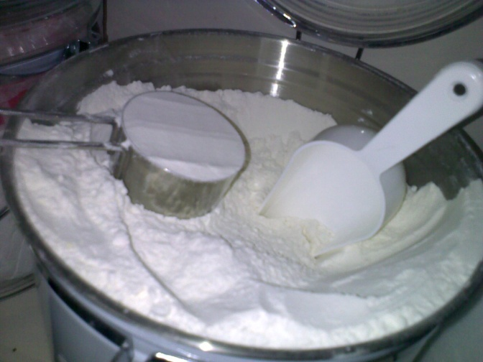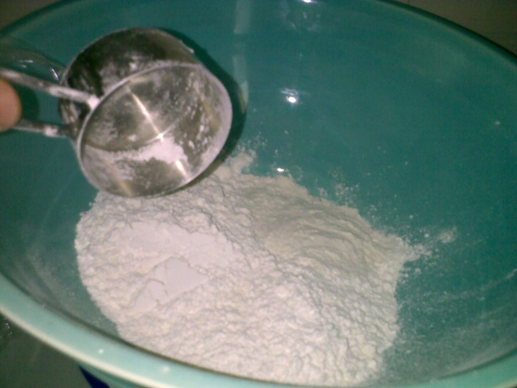
Measure the all purpose flour. Place in a large bowl, preferably a cold glass or ceramic one.
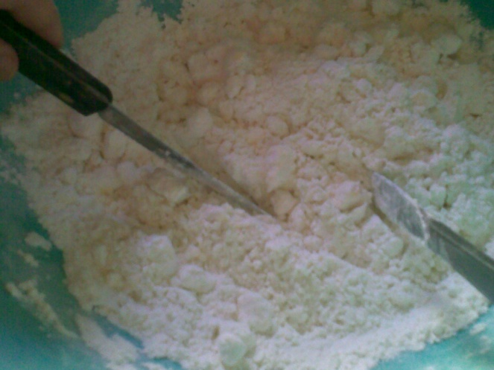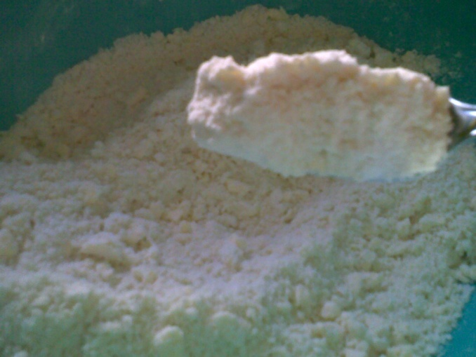
Make sure your butter and shortening is chilled and cubed in small pieces. Cut the chilled fat using two butter knives or a pastry blender until mixture becomes mealy.
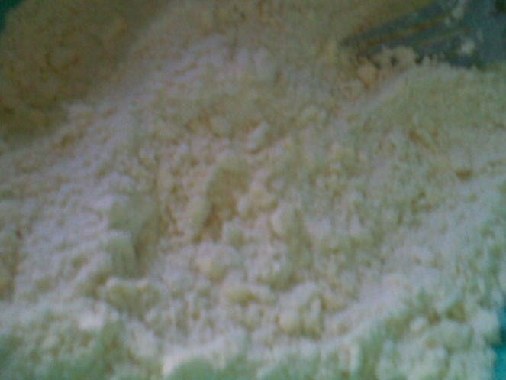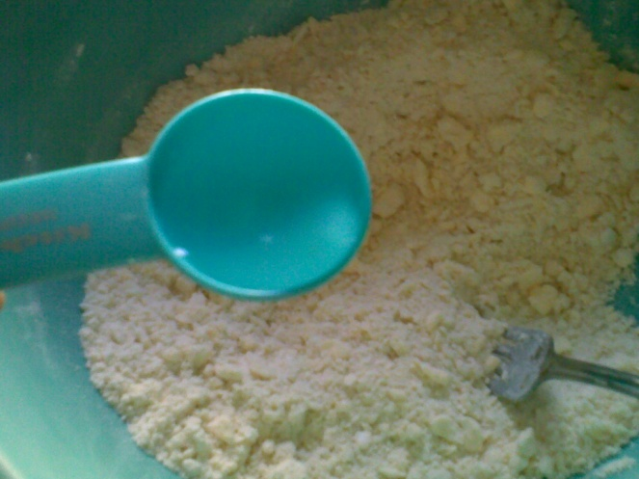
Mixture should still show bits of chilled fat. Use a fork and fluff the mixture. Add the chilled ice cold water gradually using a teaspoon while you toss the mixture with a fork tine. Work the water all over the flour/butter mixture.
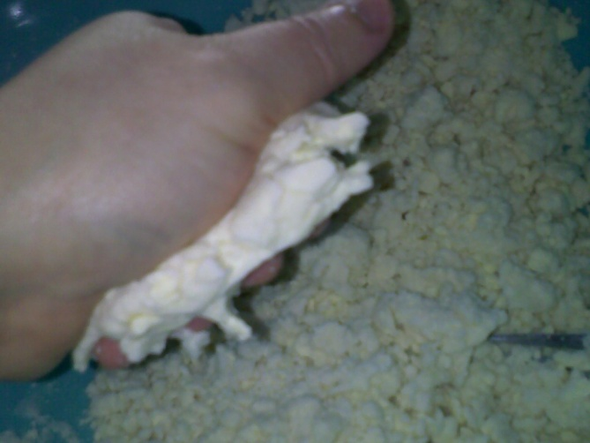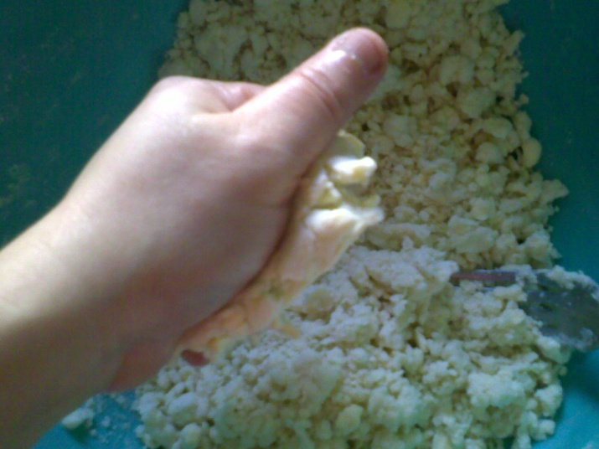
Leave out about a tablespoon of the water, check the mixture by squeezing some on your palms. If the mixture crumbles and still feels dry, add a bit more water, again by the teaspoon.
See how the mixture clumps together in the background.
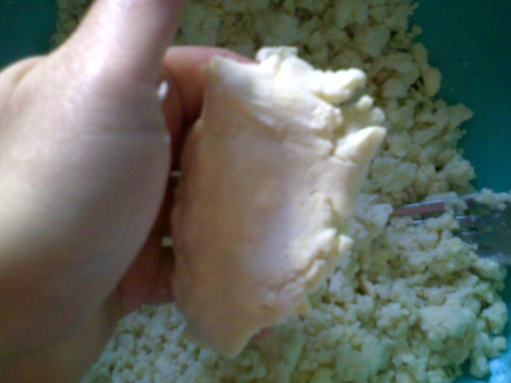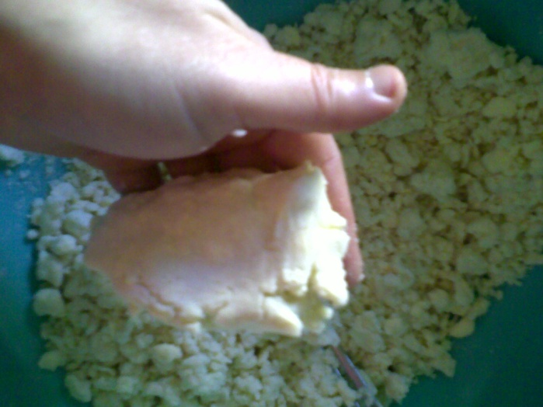
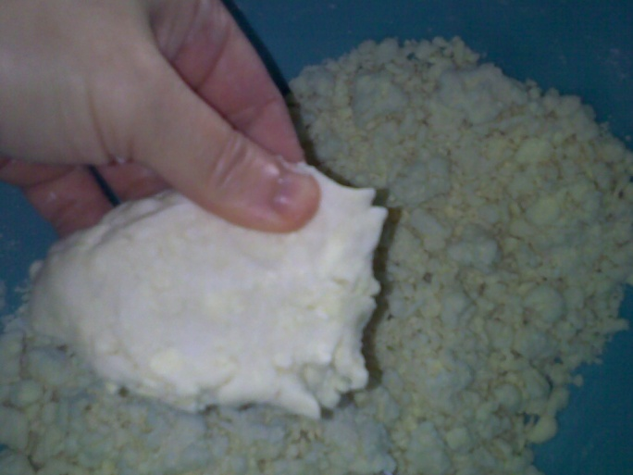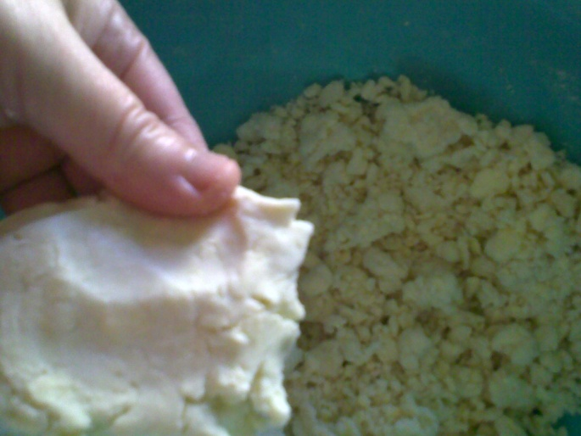
Mixture holds together into a firm but soft mass, but not wet and sticky. The pie dough does not at all stick to my fingers when I am pressing it.
Time to form the dough into two disks, one should be larger than the other because this will form the top crust.
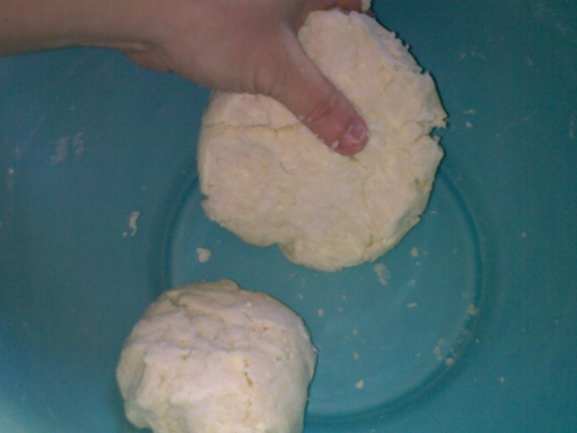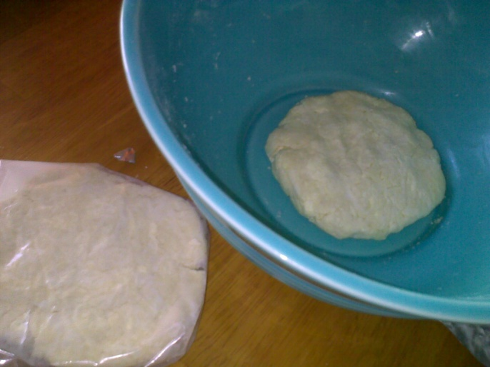
Wrap the disks in cling wrap or wax paper and rest for at least 30 minutes to an hour inside the refrigerator.
You can make your filling now, let the filling cool while the dough is resting.
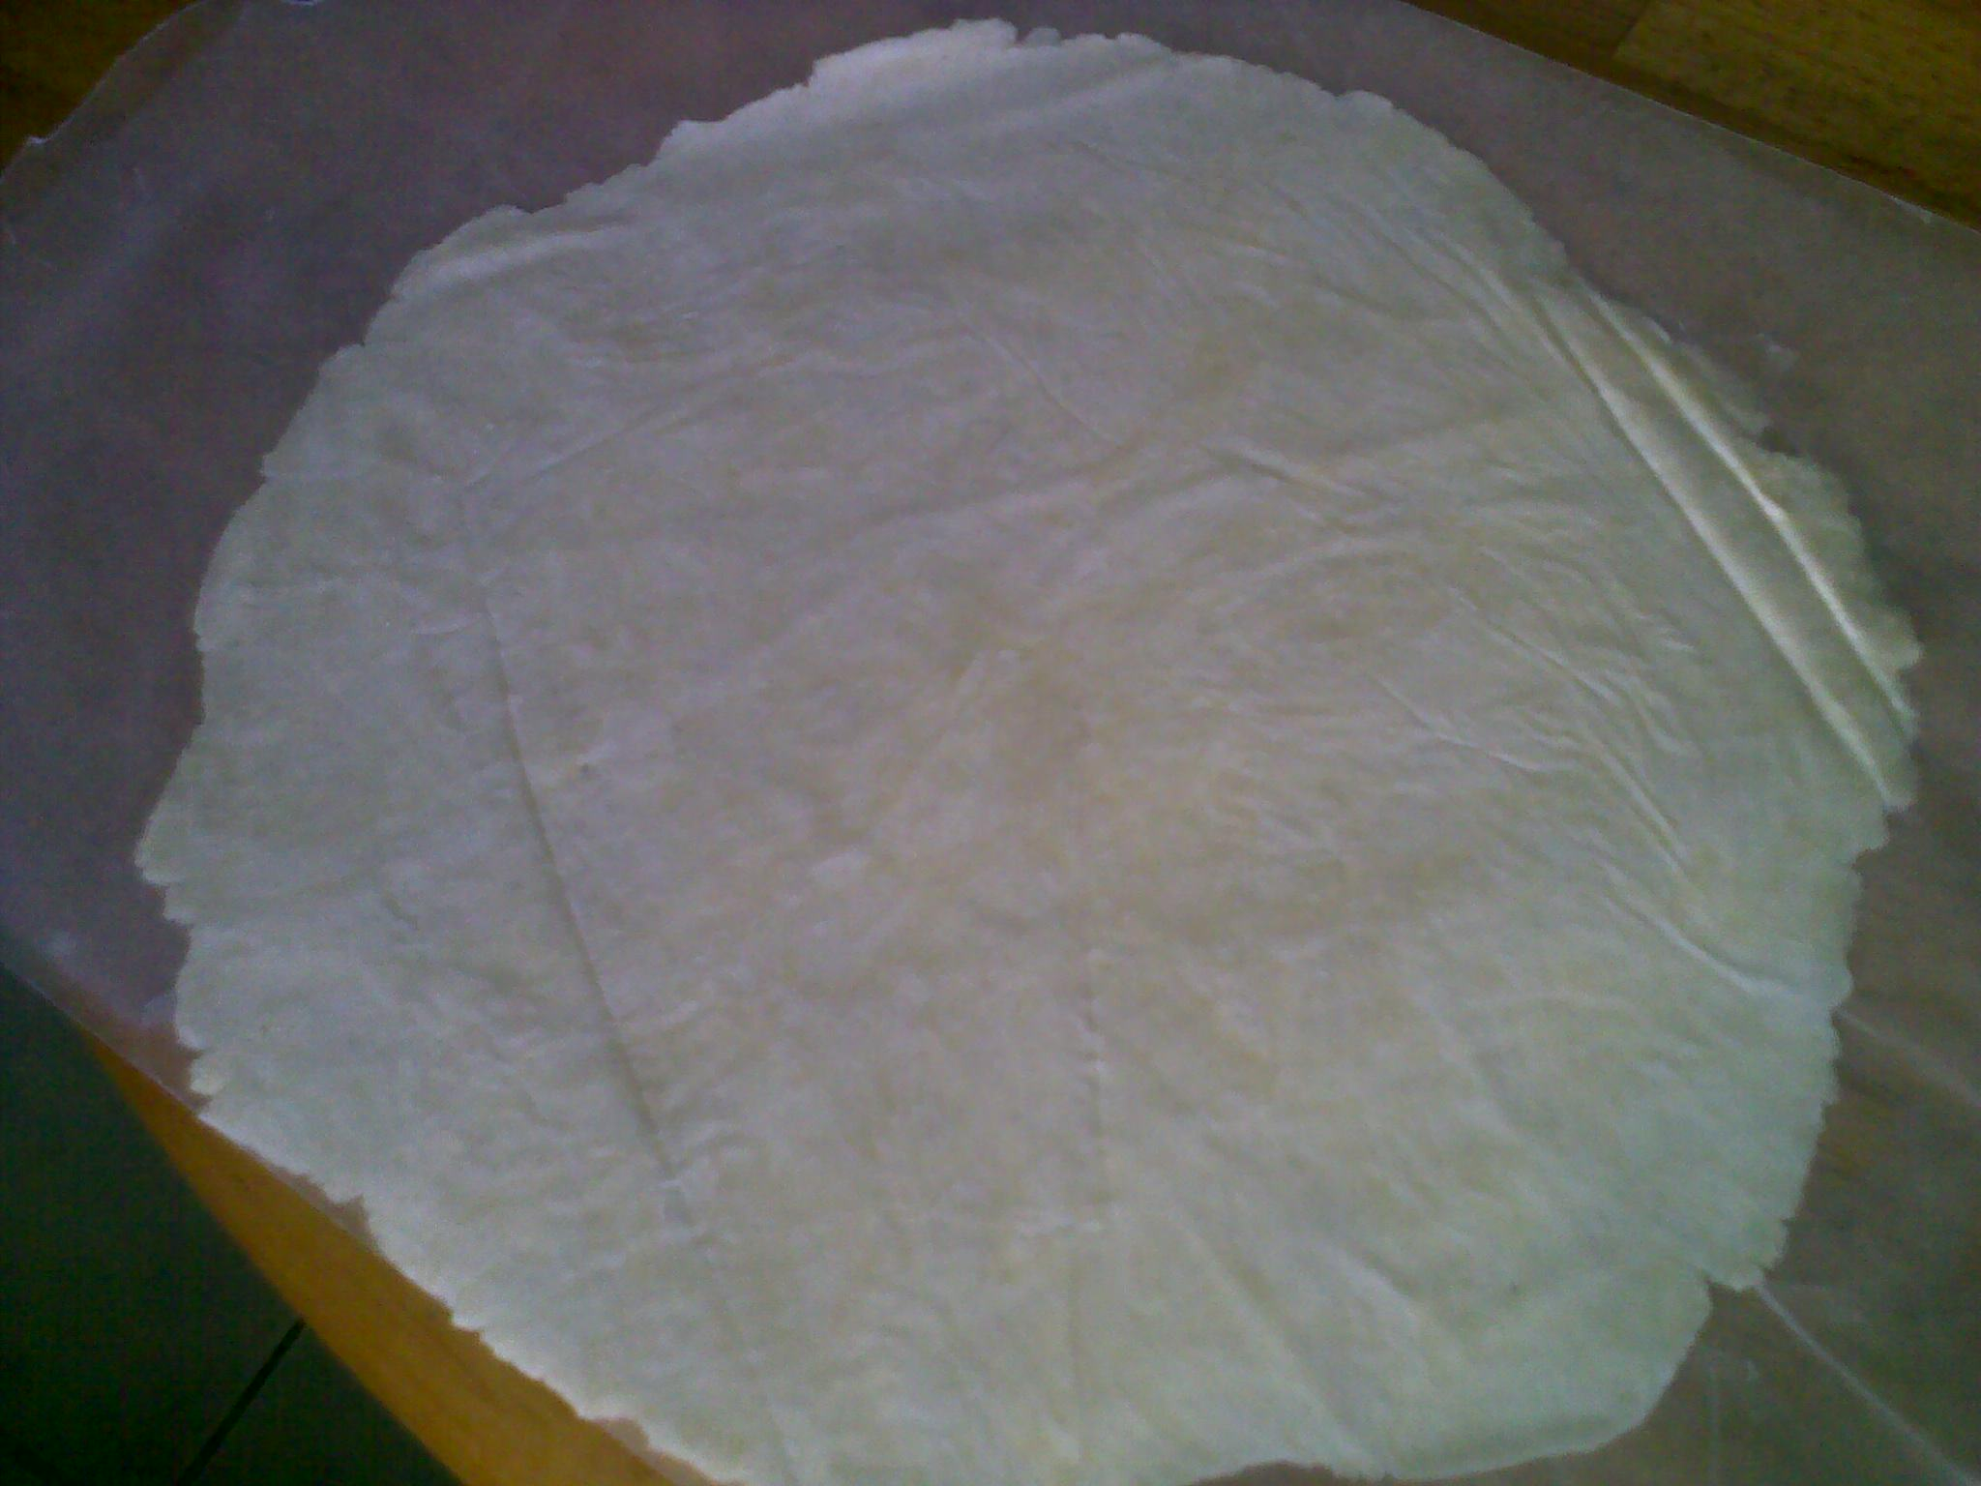
Roll the dough for the bottom crust first by placing the chilled dough in between TWO LARGE PLASTIC, NOT CLING WRAP or wax paper. DUST THE WAX PAPER or PLASTIC with flour or cornstarch first, then start rolling the crust thinly or about ¼ inch.
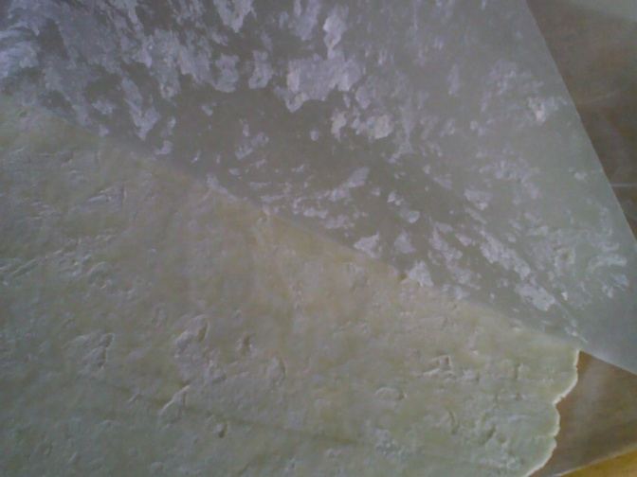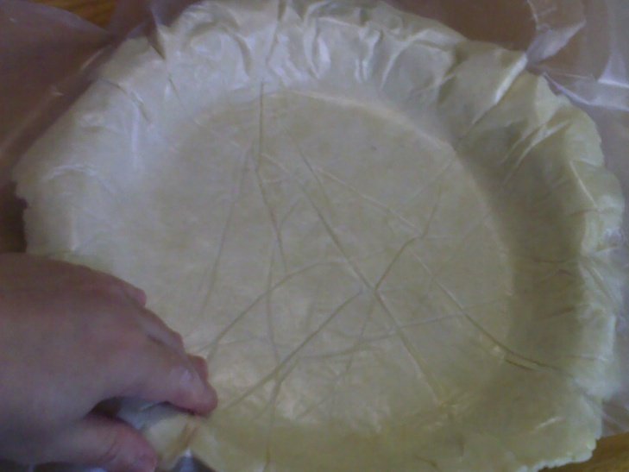
This one was not dusted so make sure you do before rolling. Lift the top wax paper, invert onto your greased pie pan and fit snugly but gently into the pan. Push the crust down to make sure the crust is even all around the round pan.
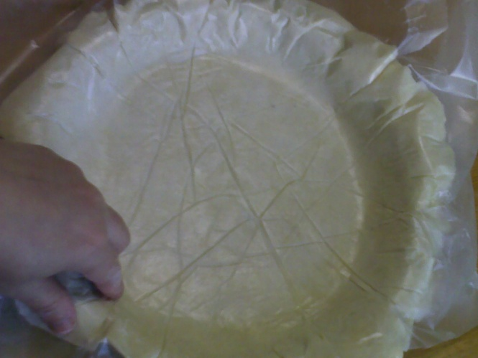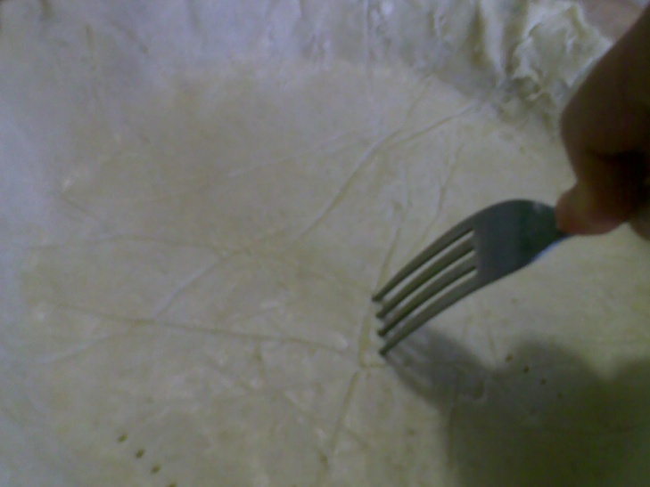
Trim the edges, I give at allowance of about ¼ inch beyond the edge of the pan for shrinkage later on, and since I will add a top crust later on, I simply fold the edges. Not too fancy because you will cover this up anyway.
Prick the crust with a fork before you bake it blind. You need to bake the bottom crust first or the thickness of the filling will result in a very long baking time and a possibly soggy crust. It is very hard to calculate the baking time when you skip this stage, so I advise that you do bake your bottom crust blind first, then top with the filling and then the crust.
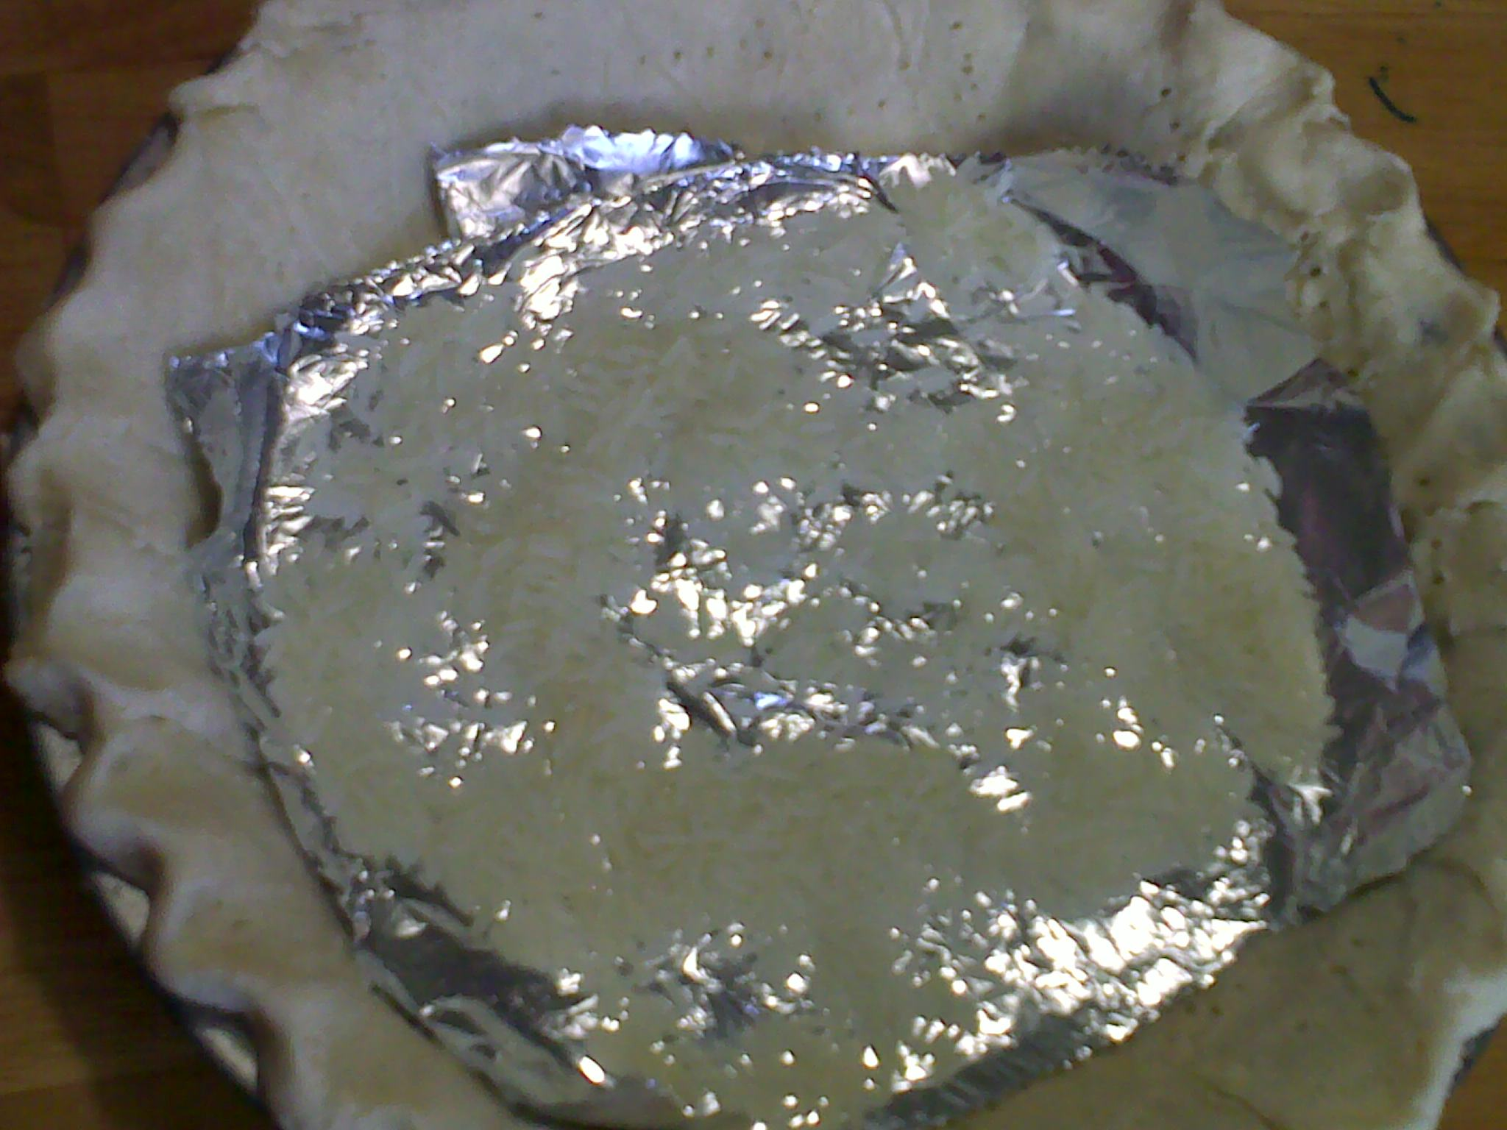
Put a foil and some rice on top of the crust. Bake for around 15-20 minutes. If the sides are starting to brown, remove the foil and rice, bake for about 10 minutes more and then remove from the oven.
The bottom crust DOES NOT HAVE TO BROWN COMPLETELY, just a light touch of color will do. You will know that your bottom crust is baked when the color changes, there is a slight rise in the dough.
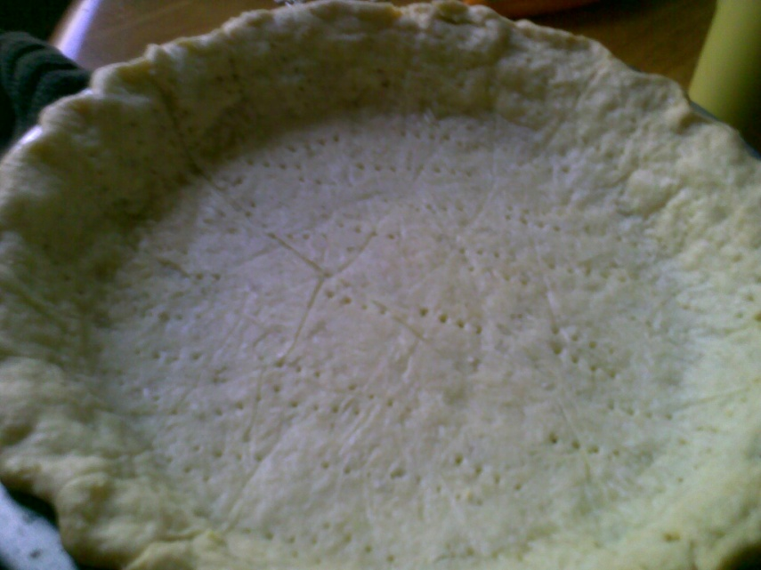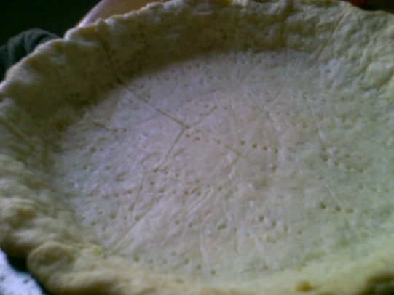
Light golden brown, the bottom crust is ready for the filling. NO need to cool the crust down, you can put the filling right away to save on gas and electricity. The oven is still on, so the best thing to do while waiting for the crust to bake blind is TO ROLL THE TOP CRUST FOLLOWING THE SAME PROCEDURE AS BEFORE, AND storing it inside the chiller, LYING FLAT ON A BAKING SHEET OR IT WILL BREAK IF SOME PORTIONS OF THE CRUST IS CURLED UP when you start to cover the pie.
Here, I already have the top crust rolled flat as thin as I want, and once the apple filling was arranged, I simply covered it with the top crust.
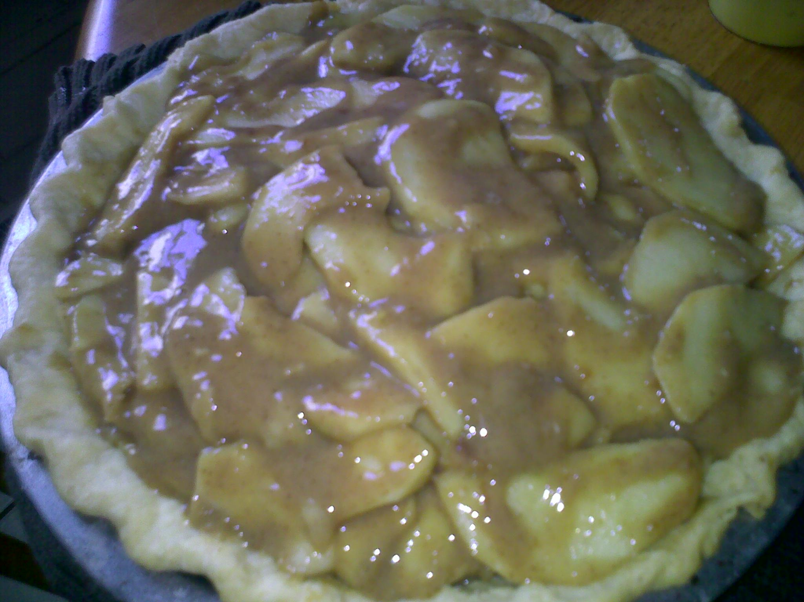
Arrange the filling in a dome to create a beautiful shape once baked. The most important thing is that your apples are evenly sliced or you will get bumps here and there.
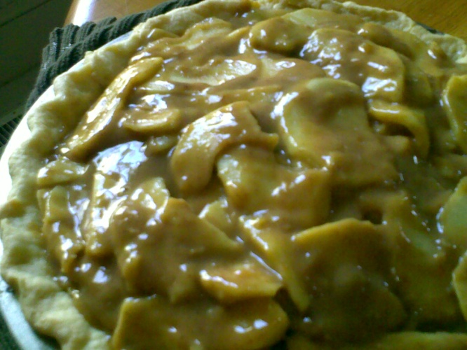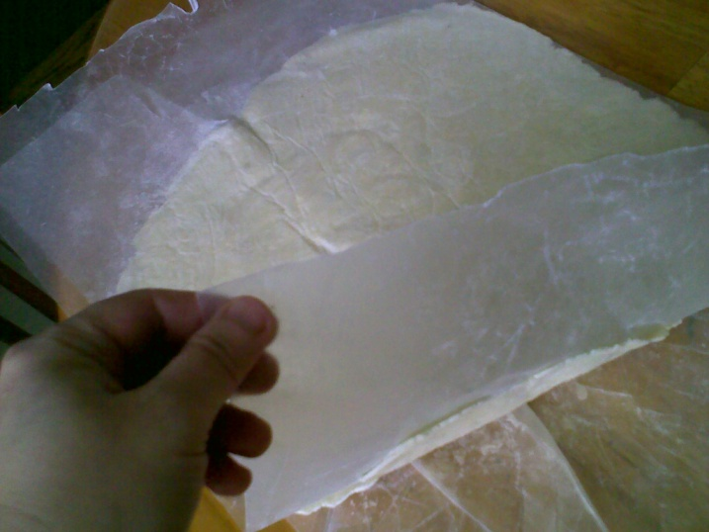
Roll the crust, remove the wax paper, turn it over and release the bottom wax paper so you will have an easy time removing it later when you flip it on top of the pie. 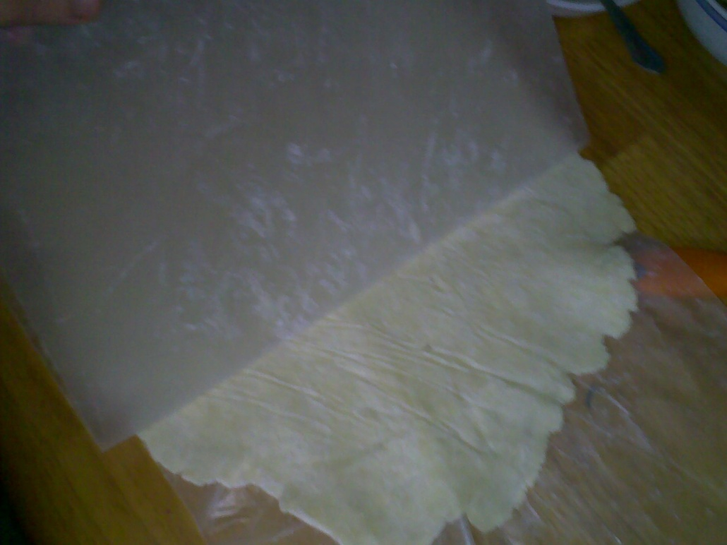
Both wax paper should be removed, the size of the top crust should be than the size of your pan, leaving at least 2 inches of overhang around the side.
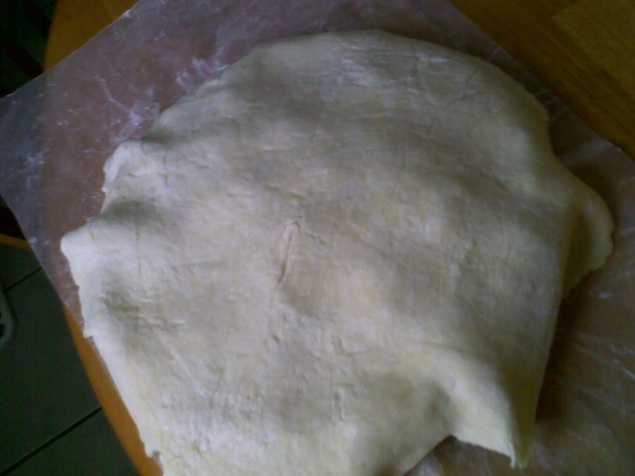
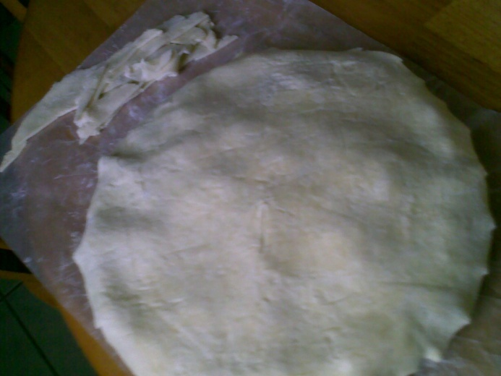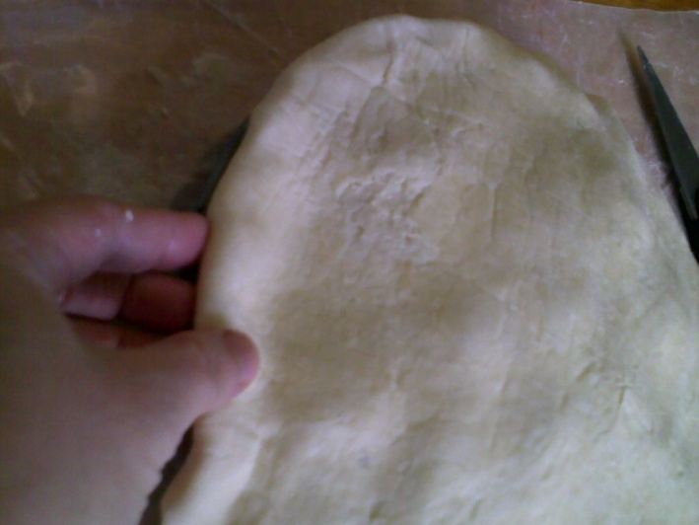
Cut around the edge leaving about half an inch overhang for folding. The crust will shrink somehow so do not trim to the edge, the overhang will ensure that the pie will still look pretty snug to the pie pan.
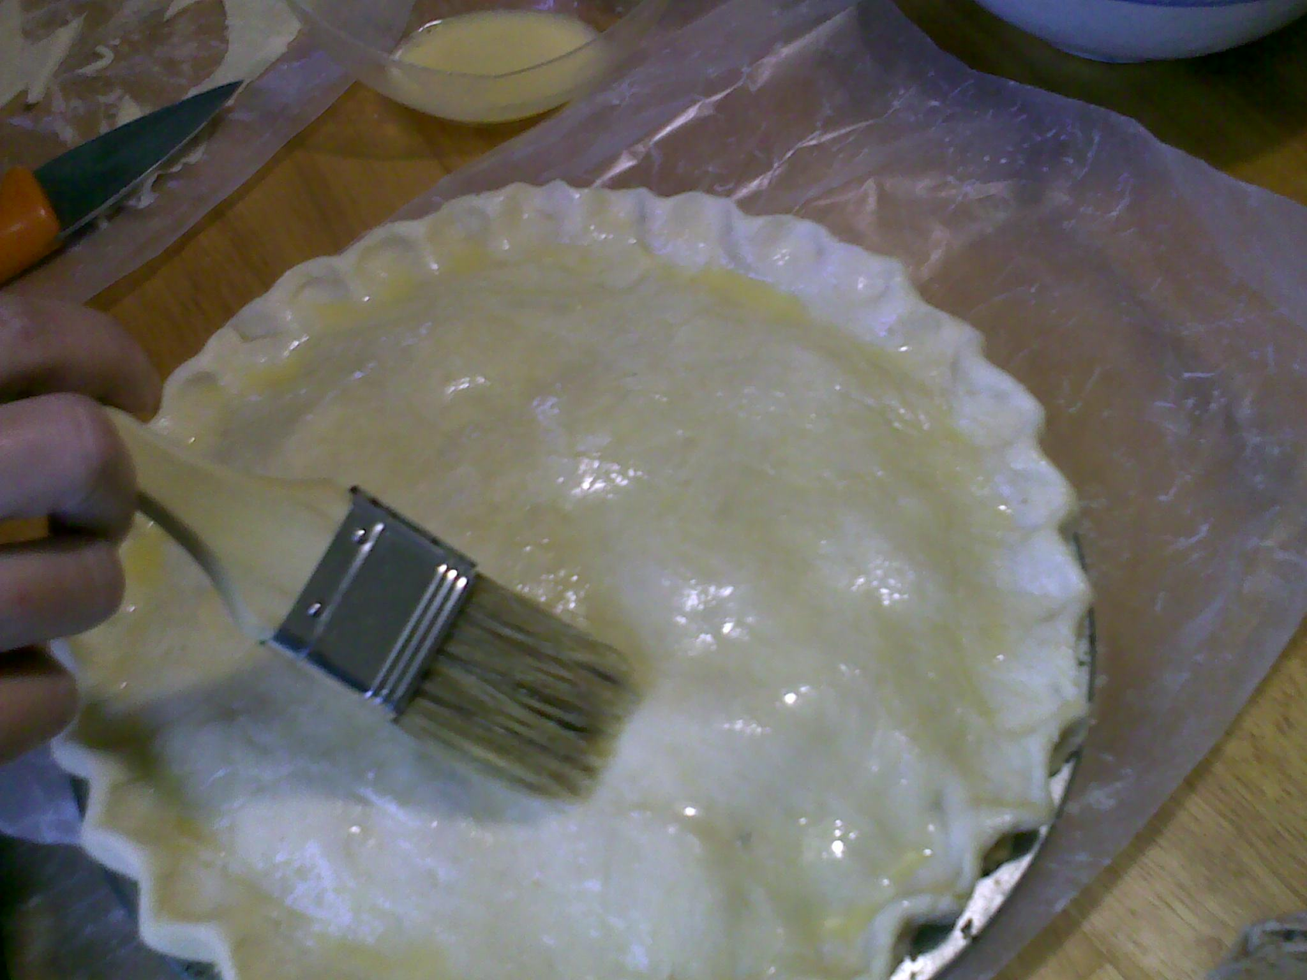
Brush the top with an eggwash after sealing the border. Beat one egg with two tablespoons of water and glaze the top and edges.
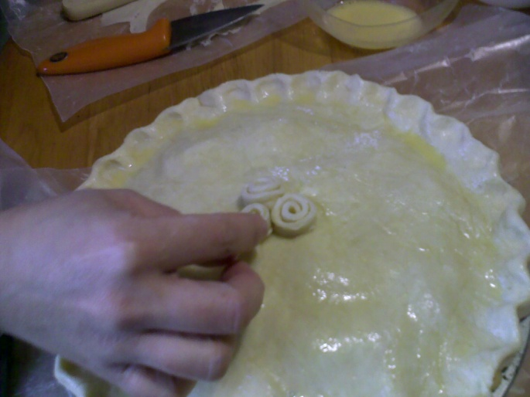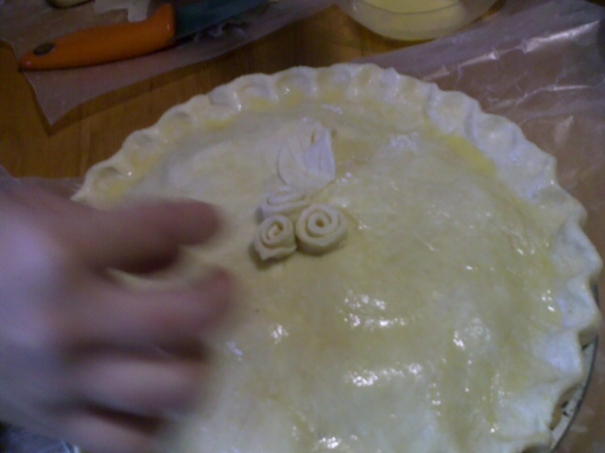
Using scraps, roll them as thin as possible, then cut strips to make the Roses and leaves. Arrange them on top of the glazed crust (so they would stick), then brush them with the eggwash.
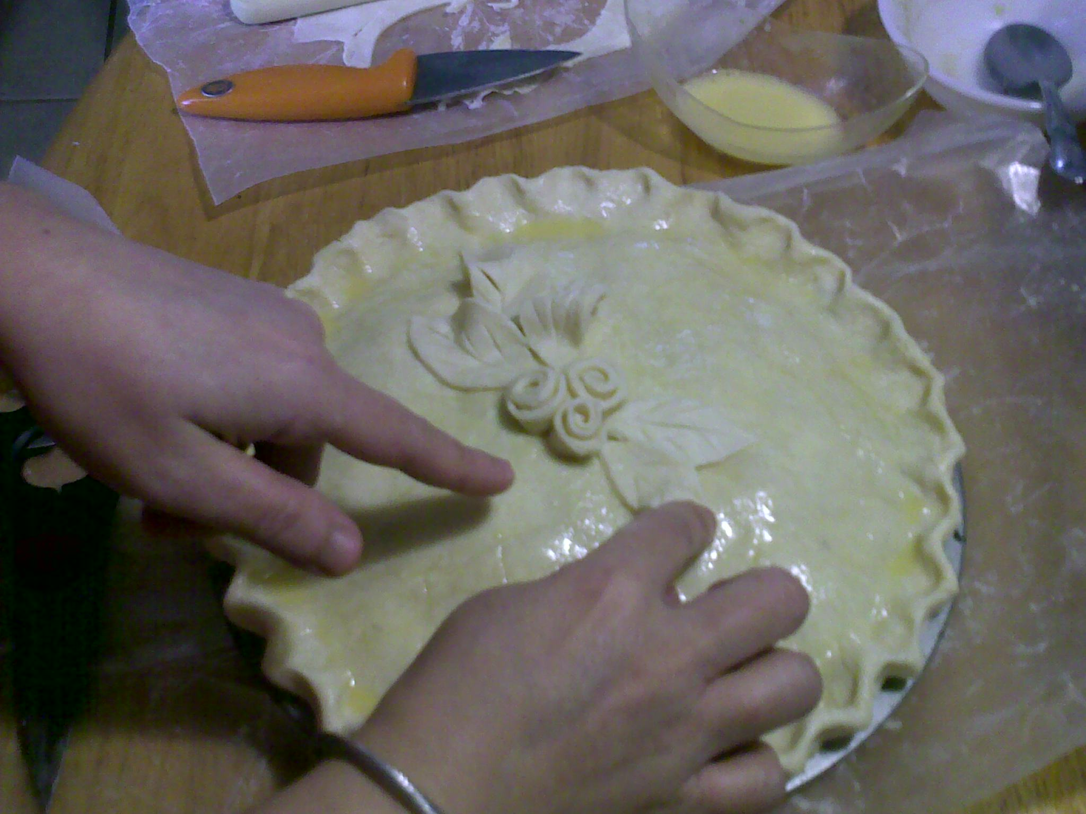
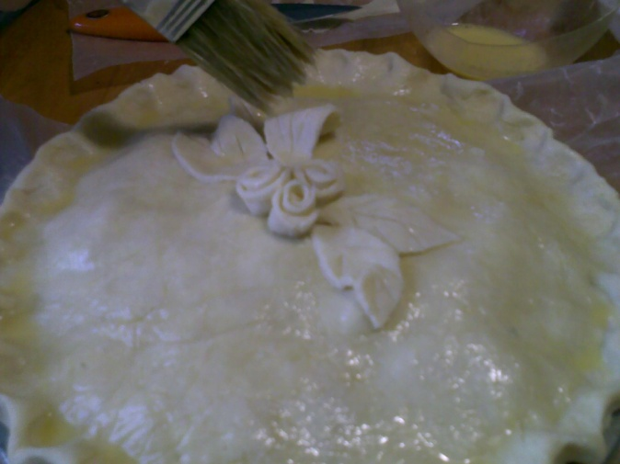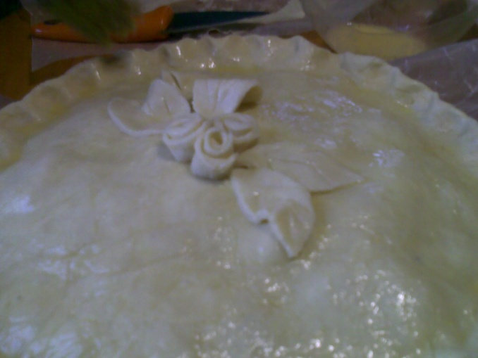
Curl up the leaves or they will flatten out during baking. Slash the top using a sharp knife, about 5 times around the decorative top to release the steam during baking.
Bake at 325 F for 45-60 minutes. Top should be a glistening golden brown color.
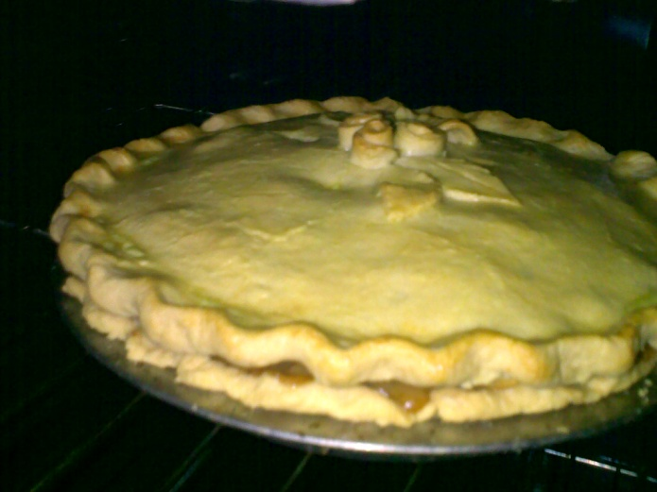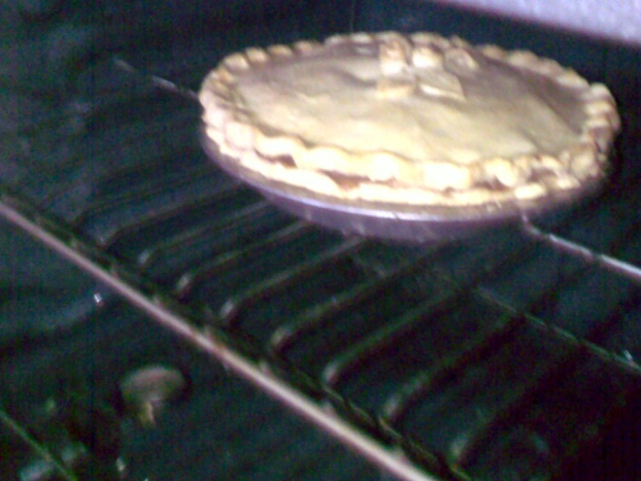
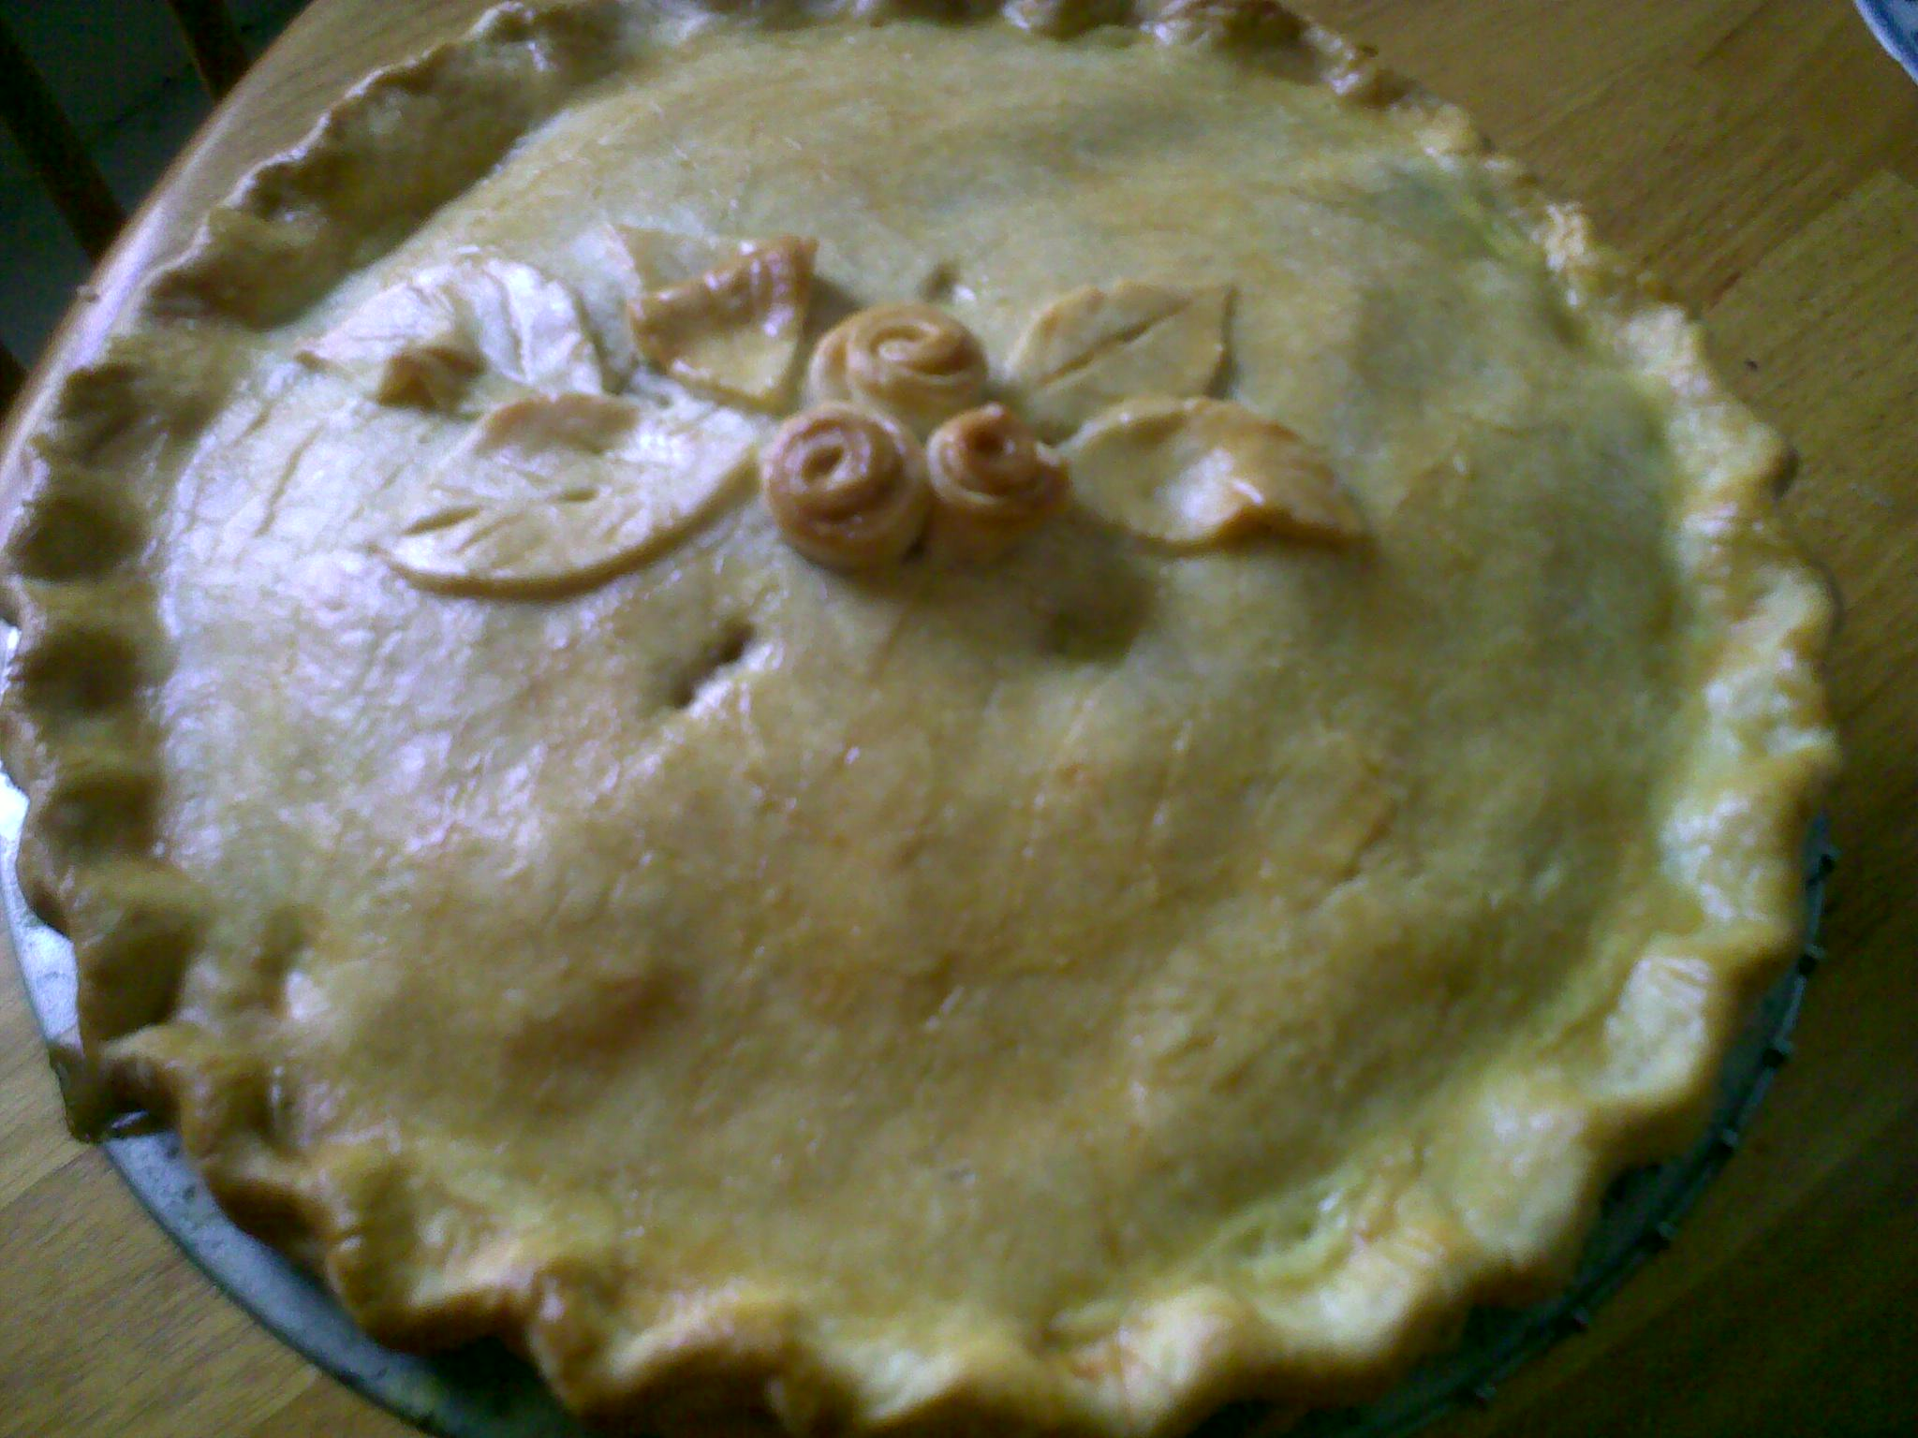
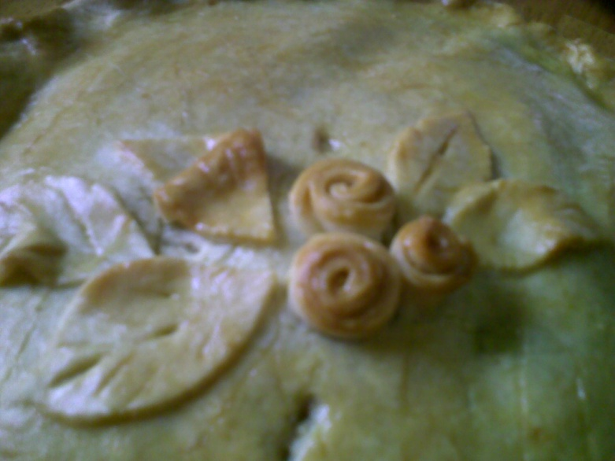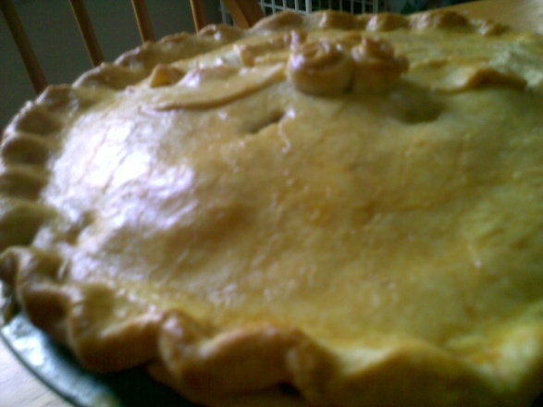
Cool the pie for about 30 minutes on a rack before slicing. The cornstarch in the filling will firm up and it will make a neater slice. No need to cool it completely, you can enjoy the warm pie with a scoop of your favorite vanilla ice cream.
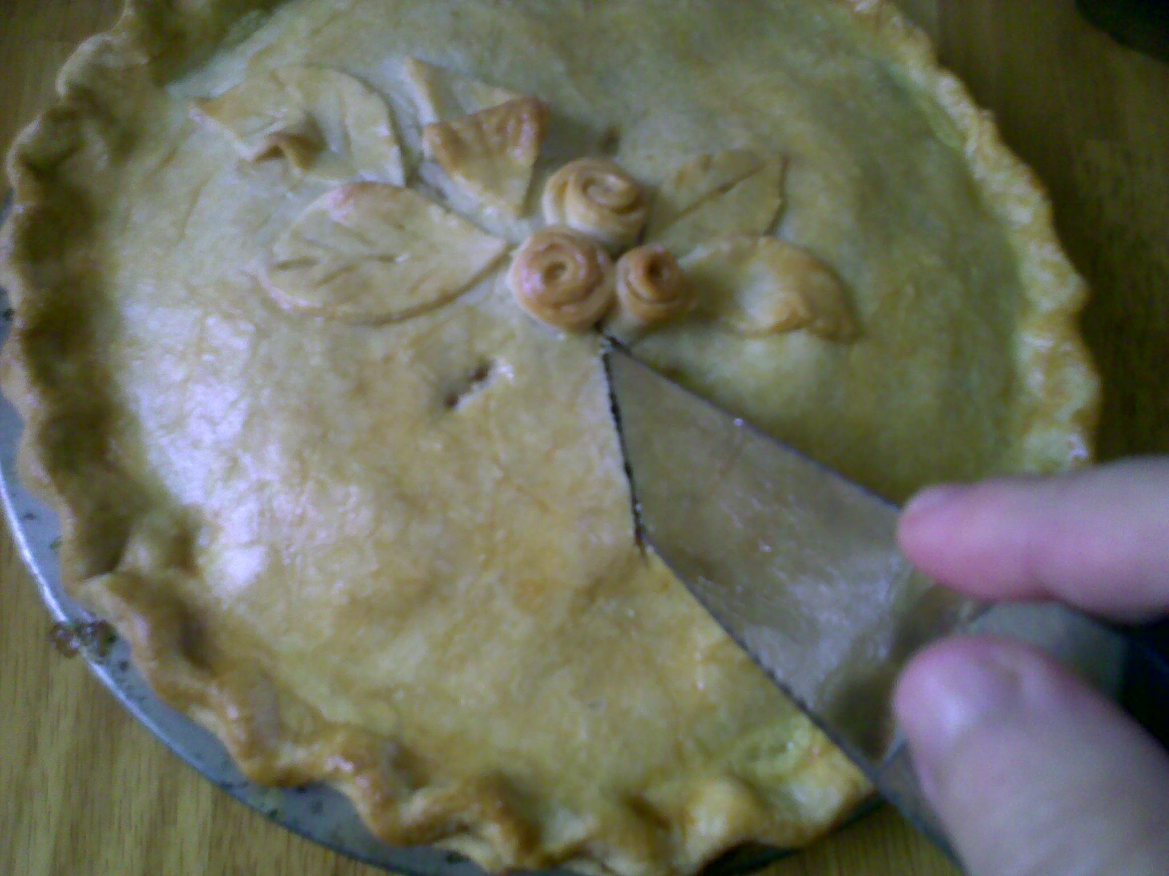
I can’t wait to get a slice! Use a sharp knife for this task.
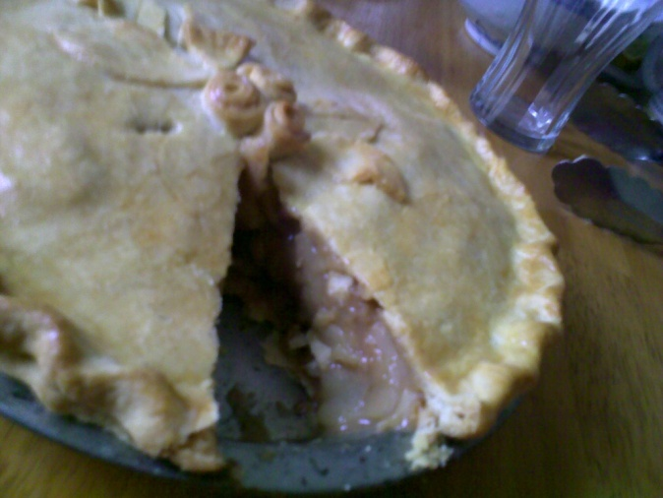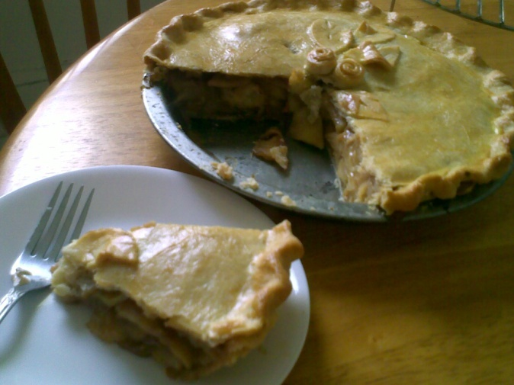
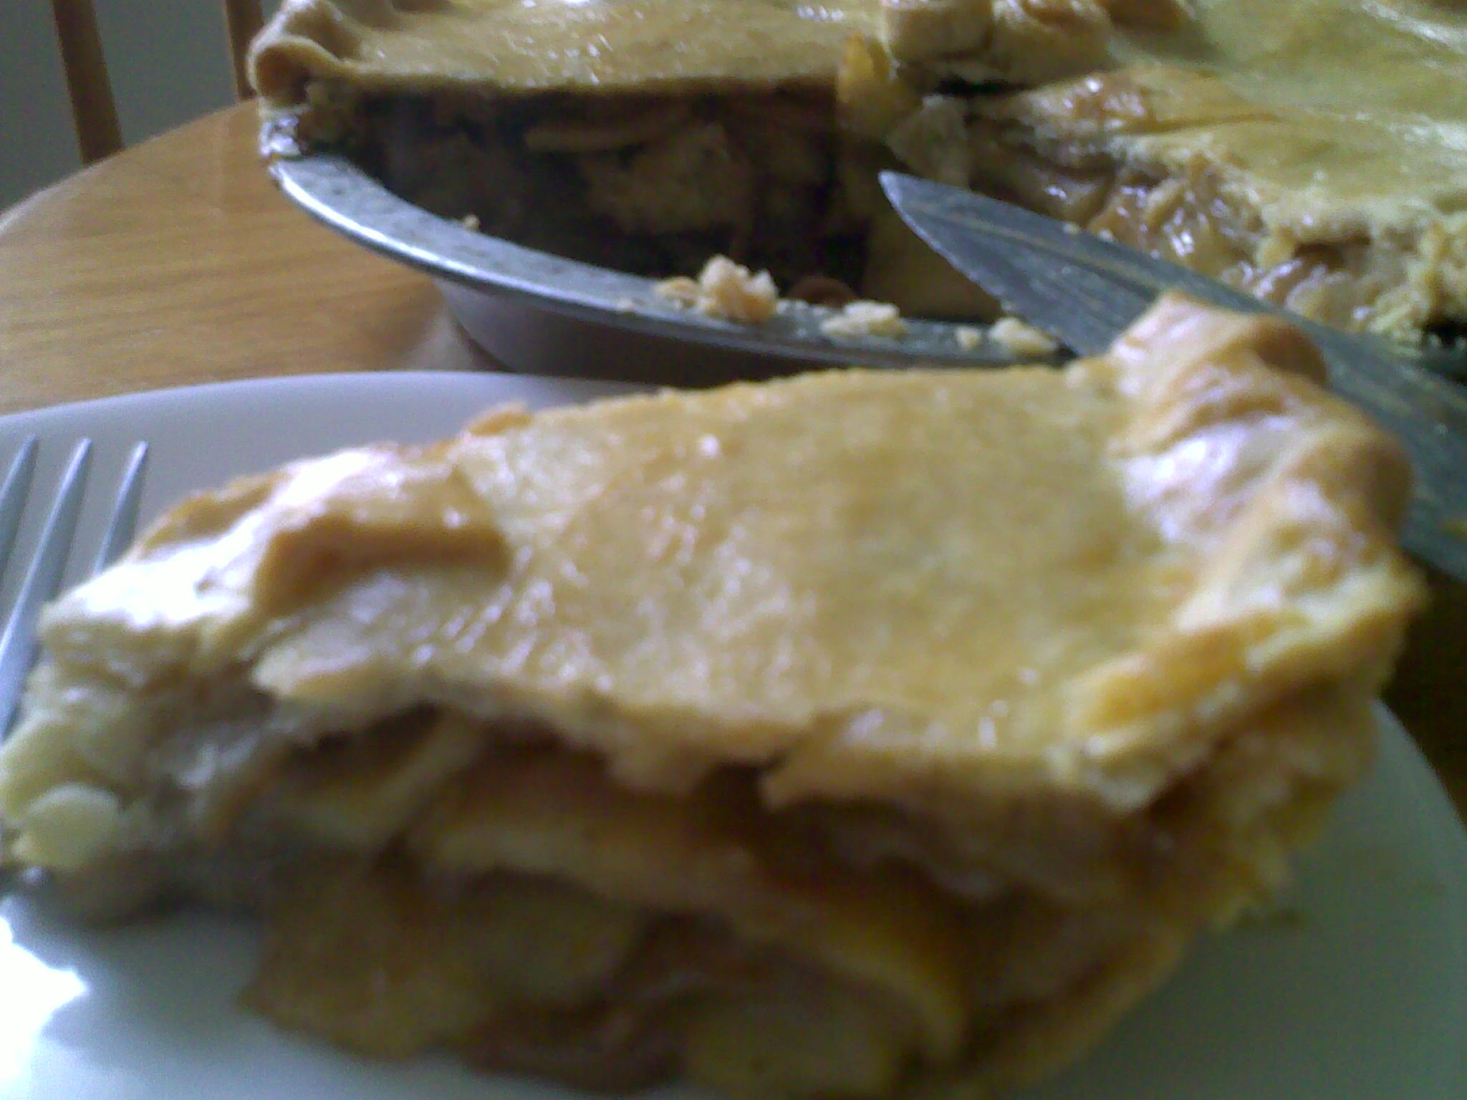
The crust is thin and crispy, just right for the amount of filling of 7 large sized Granny Smiths.
ENJOY!

The Filling:
Granny Smiths 7 large pieces sliced about ¼ inch thin.
Brown sugar ½ cup
Salt ¼ teaspoon
Egg yolks 2 pieces
Cornstarch ¼ cup
Vanilla 1 teaspoon
Cinnamon powder 1-2 teaspoon, adjust to taste
Butter 2 tablespoon
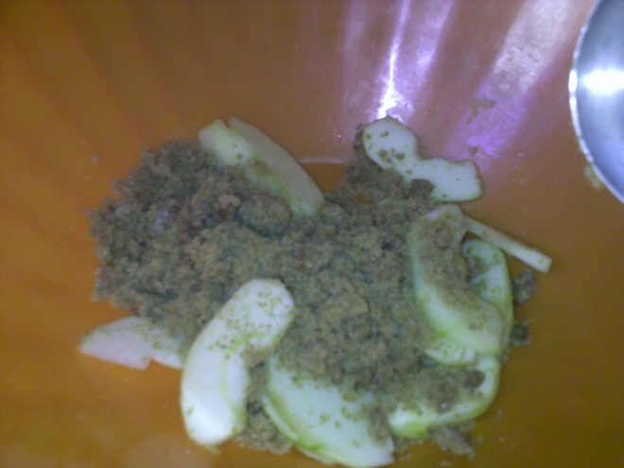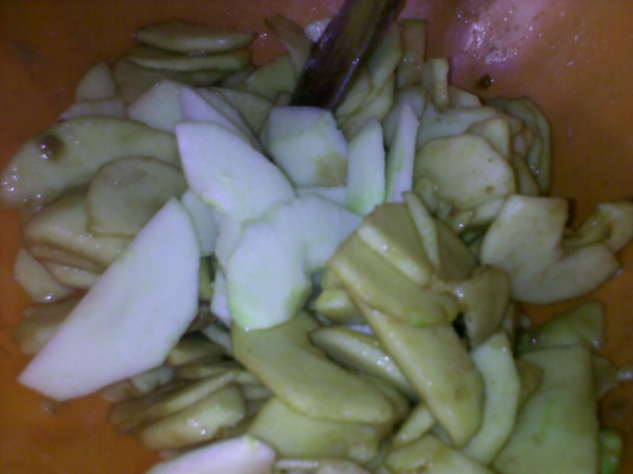
Place the brown sugar in a large bowl together with the cinnamon powder, salt, vanilla and cornstarch.
Add the slices of apple into the bowl, stirring gently to sugar coat them. No need to add lemon to prevent browning as long as the apples are coated with the brown sugar mixture. Granny Smiths are sour already, so adding the usual lemon juice or vinegar will increase its acidity. Just make sure to dump the slices directly into the brown sugar and stirring gently afterwards.
The apples will macerate, do not panic because you will reduce the liquid later on during cooking.
After slicing all the apples, put them in a large saucepan, and add the eggyolks and butter.
Cook over low heat, gently stirring every now and then until the sauce or liquid thickens slightly. Do not overcook.
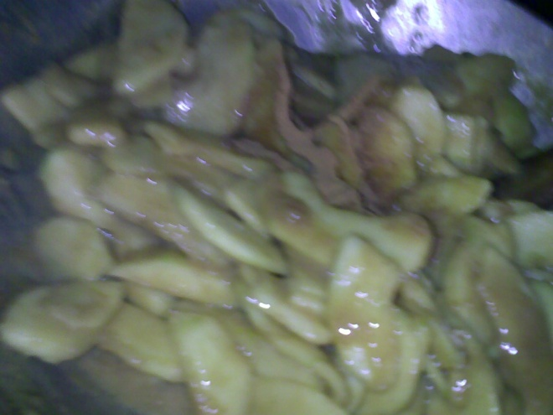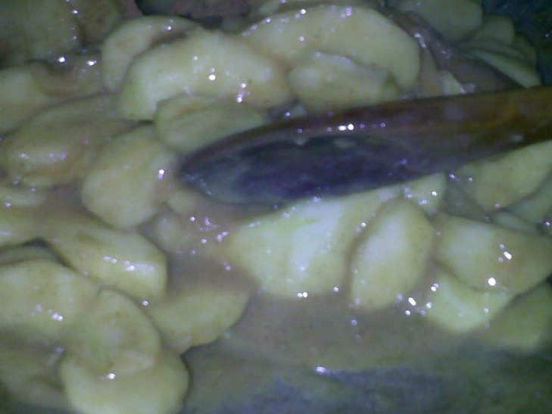
The sauce should be slightly thick, taste if you need to add a bit more sugar before the sauce finish thickening because the extra sugar will create added liquid to the filling, creating a soggy bottom crust.
Cooking the filling will take around 25-30 minutes over low flame, remove from heat once it is done.
SANS RIVAL
Layers of Merengue and Buttercream, topped with toasted Cashew Nuts. This recipe has a twist on the icing, the Buttercream is folded with heavy whipping cream to reduce the sweetness. Perfect for a dinner party!
Merengue:
Eggwhites 5
Granulated sugar 1 cup
Cashew nuts 1 cup, chopped coarsely, semi-fine, toast ahead of time and cool
Cream of tartar ½ teaspoon
Vanilla extract ½ teaspoon
*all purpose flour 1 tablespoon, optional (to add strength to the merengue)
YOU WILL NEED:
Parchment paper
Springform pan, 9-inch
Baking sheets, 2 (18 by 13 inches) or individual baking sheets of 9 by 12 inches.
8-inch cake pan or plate
Shortening for greasing, or butter
Flour for dusting
Procedure:
Trace on parchment paper 5-6 rounds using an 8 – inch plate or cake pan.
Turn the paper over, the pen or pencil lines should be at the bottom. Grease the circle heavily and dust with flour. You will pipe the merengue over the rounds later. Depending on the thickness of the merengue you make, you will at least have 5 thick ones or 6 thin merengue rounds.
Preheat the oven to 320-325 F. If you are using a small oven, use 320 F, for larger ovens (4-sheeters), you may use 325 F. If you prefer light pale merengues, use a much lower temperature.
In a grease free mixing bowl, whip the eggwhites at Speed 6-7 (Kitchen Aid) or medium speed if you are using a hand held mixer. Once the whites foam, add the cream of tartar and the sugar gradually.
Do not add the sugar all at once or it will deflate the air bubbles formed during the whipping.
Whip until stiff peaks form. Fold the vanilla and toasted cashew nuts.
Divide the merengue on the traced parchment rounds, or use a piping bag, pipe on the center of the rounds and spread thinly. For thin merengues, spread at least ¼ of an inch. To avoid dragging the paper while spreading the merengue, grease four corners of the parchment paper.
Bake the merengues until light golden brown, turn off the oven and cool inside for at least two hours. You can do this ahead of time, store the merengue rounds in an air tight container, then assemble later.
BUTTERCREAM
Eggyolks 5
Granulated sugar 2/3 cup
Water ¼ cup
Unsalted butter 1 cup, cut into small cubes
Chopped nuts, toasted 1 – 1 ½ cups
Procedure:
Using your whisk attachment, whip the yolks in a mixing bowl at low speed until pale light yellow in color.
While doing this, mix the water and sugar in a heavy duty saucepan and cook the syrup to firm ball stage. Refer to the Italian merengue buttercream recipe.
Pour the syrup in the whipped eggyolks, by turning the mixer off and then turning it on to the highest speed. Once all the syrup has been added, reduce speed to the lowest and cool the mixture down. You can also refrigerate it while you cream the butter.
Cream the butter then add to the yolk/syrup mixture.
ASSEMBLY:
Place one disk of Merengue on the 9-inch springform pan. Add a thin layer of Buttercream, then sprinkle with chopped nuts. Repeat the process, reserving at least a cup of Buttercream for the icing later on.
Whip 1 cup of heavy whipping cream, add the Buttercream gradually until well blended. Place in a piping bag fitted with any rosette or star tip.
Pipe around the side of the cake and make rosettes on top.
Cover the cake with cling wrap and freeze. The merengue will soften at room temperature so this cake must be served frozen or chilled.
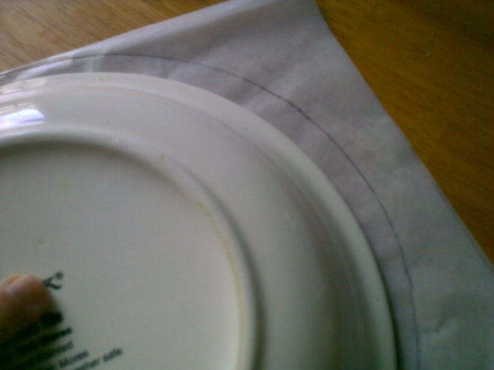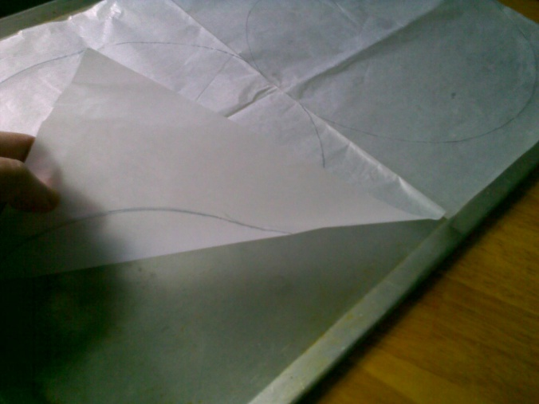
You need a circle smaller than the size of the pan you will use to form the Sans rival. The merengue will eventually rise during baking. Turn the parchment paper over on a baking sheet.
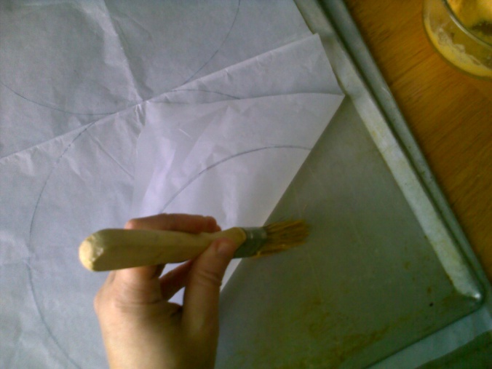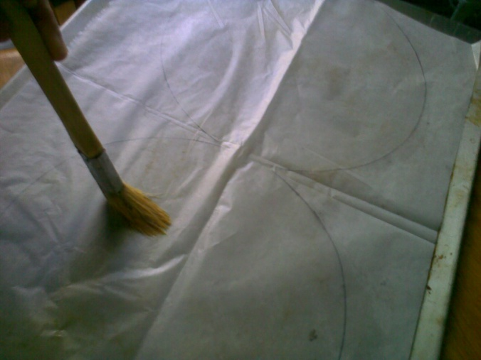
Grease the bottom of the baking sheet and the traced circle on top. To prevent sticking later on which will be a huge problem as merengue breaks easily, grease the parchment paper HEAVILY, THEN DUST WITH CAKE FLOUR.
If you have no 18 by 13 baking sheets, use any baking sheet that will fit an 8 inch parchment round.
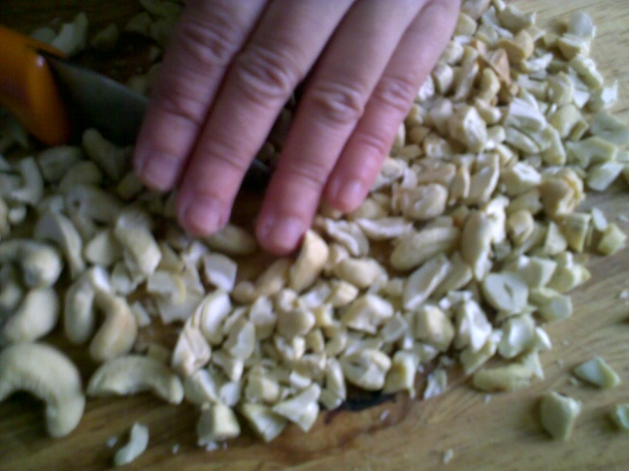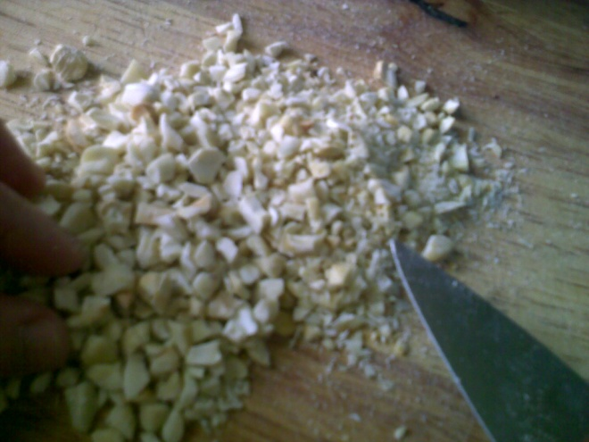
I like to use a coarser chop for the topping and layering, the finer chop on the right for the merengue rounds. Toast the cashew nuts ahead of time, set aside and store in an airtight container to keep them crunchy.
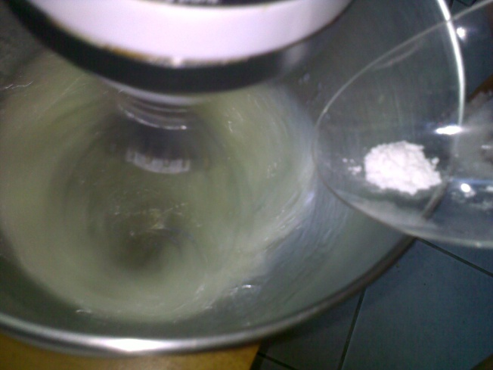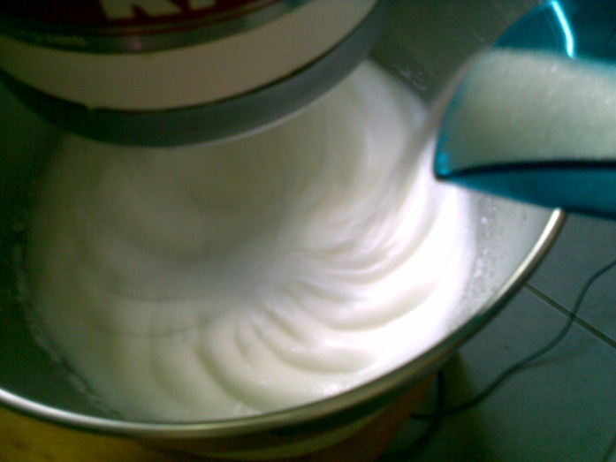
Whip the eggwhites until it is frothy, add the cream of tartar, then the sugar gradually.
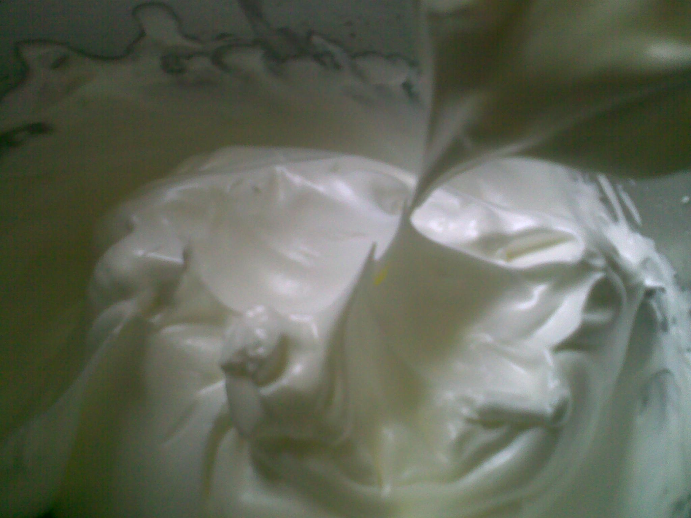

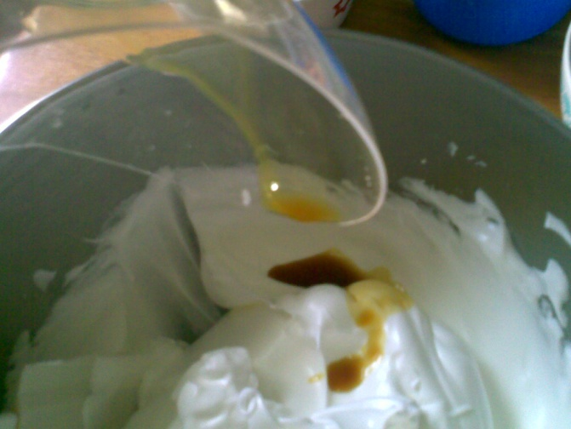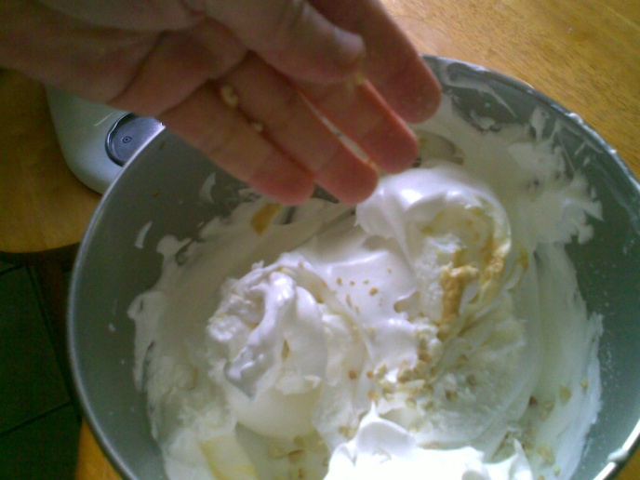

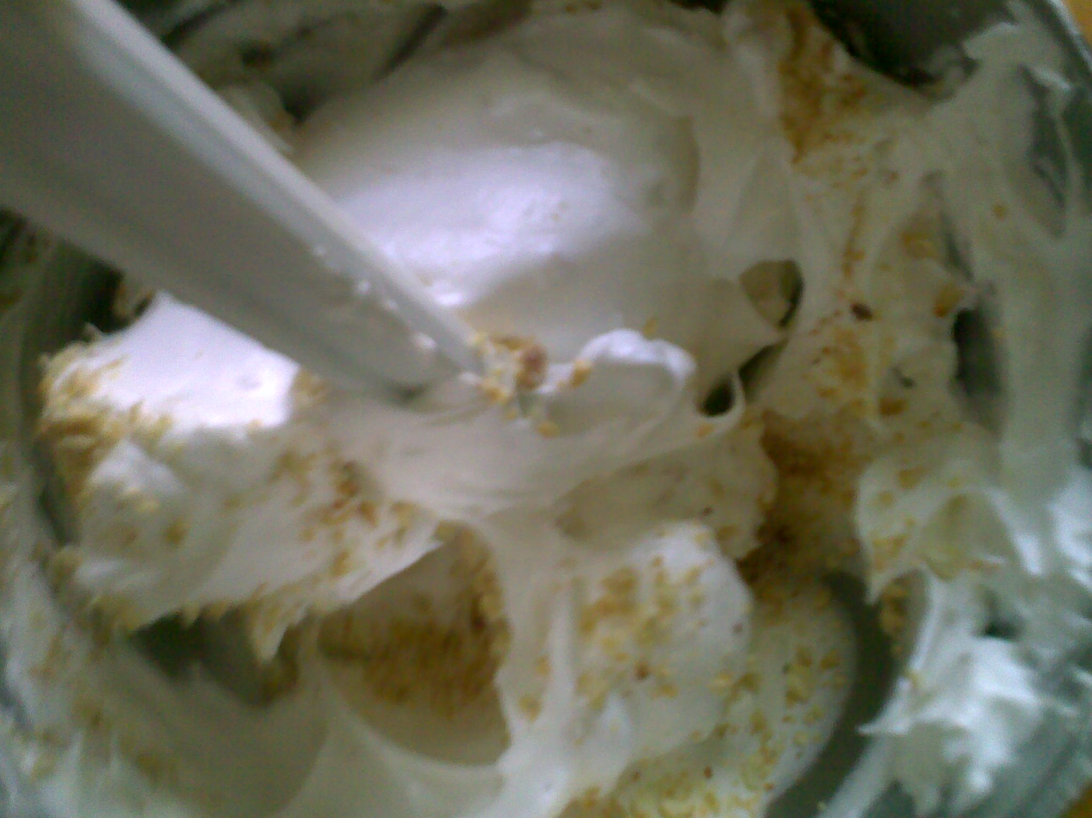
Fold the vanilla and toasted cashew nuts gently. If you are using the all purpose flour, you can fold it at this stage, by sifting it on top first and then fold.
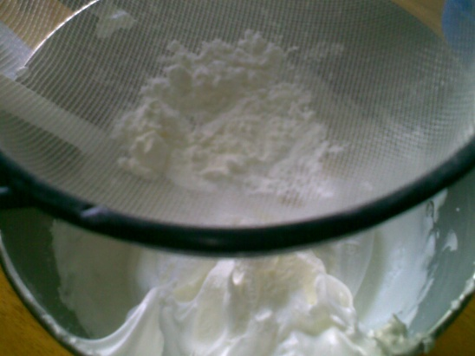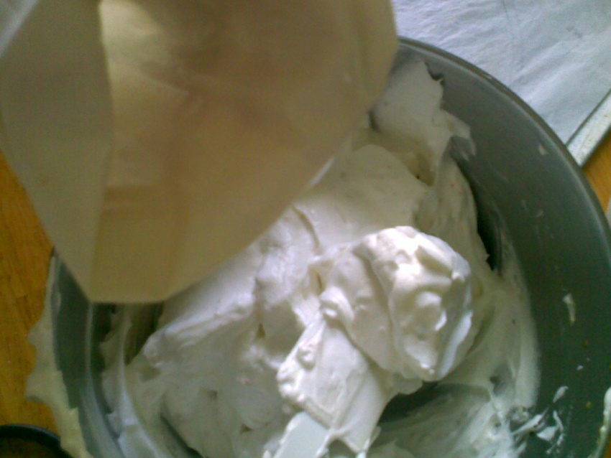
Place in a piping bag with no tip, or simply spoon onto the center of the parchment rounds and spread using a tapered offset spatula or butter knife.
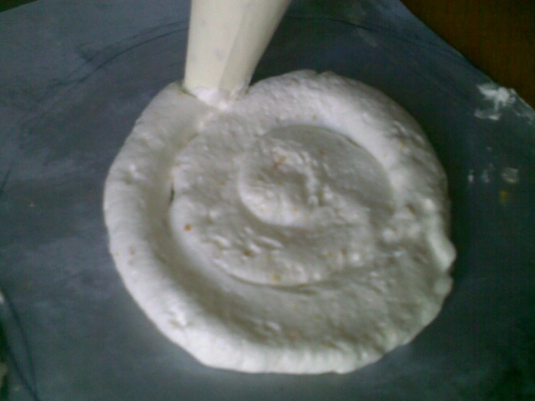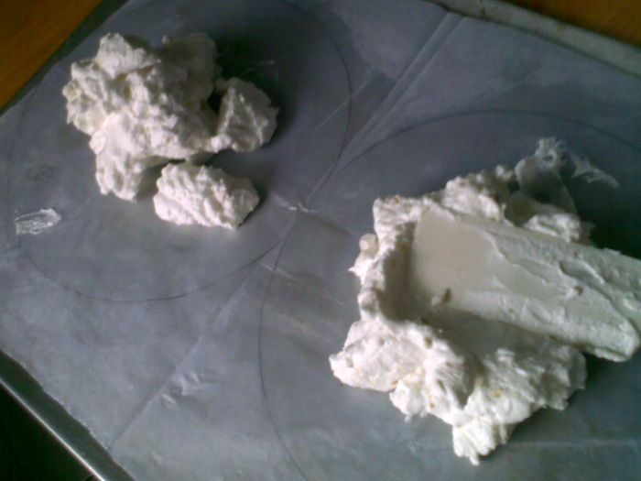
Whichever you find easier is fine. No pastry bag means less clean up.
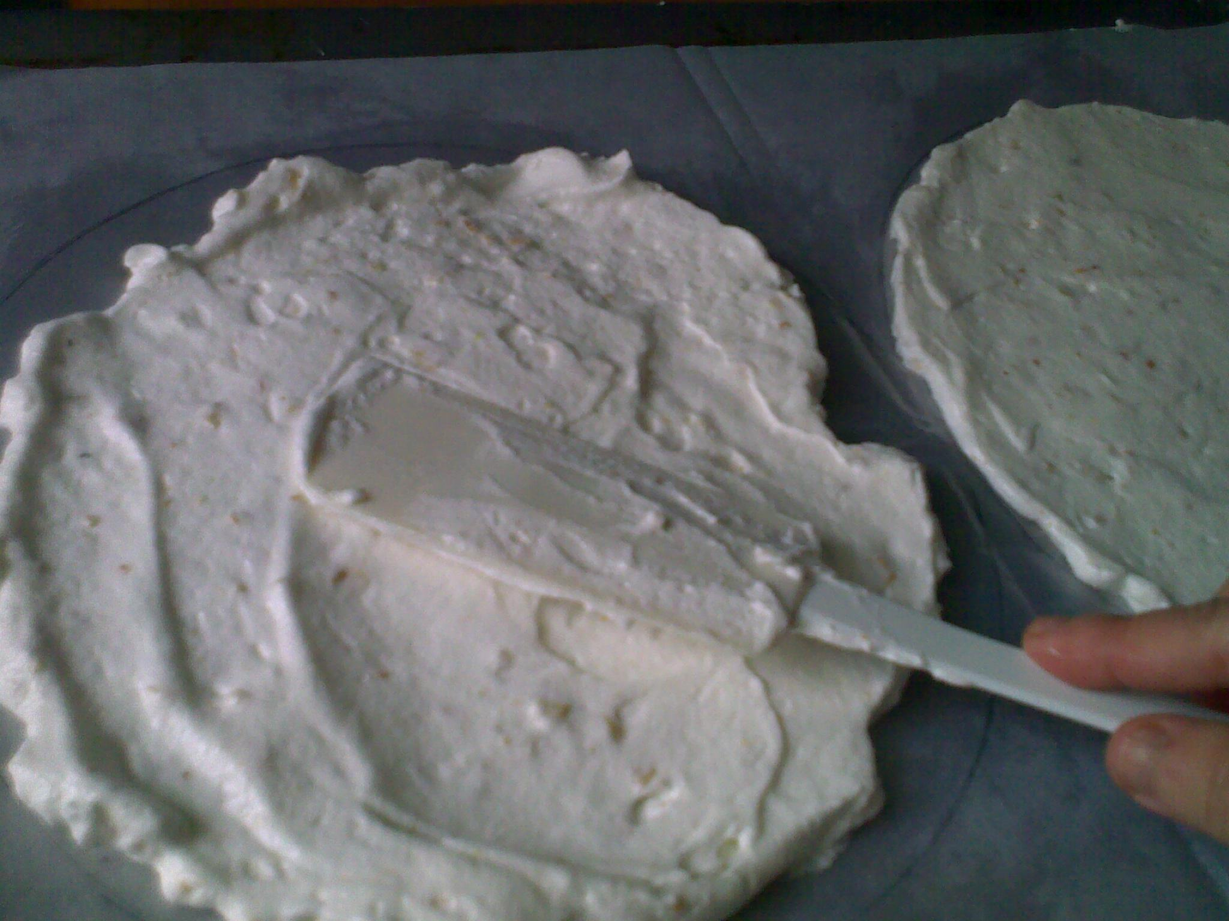
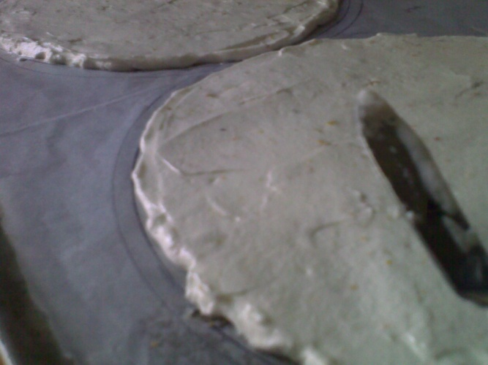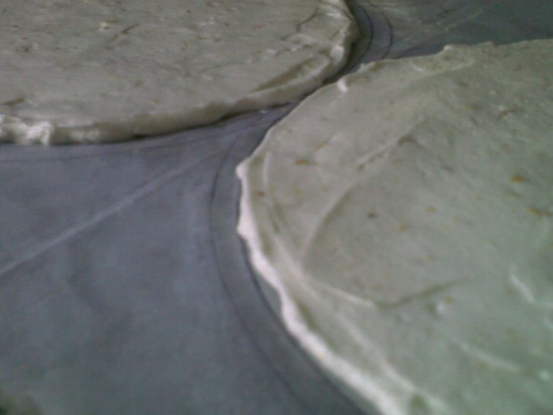
Again, it does not have to be as thin as this. I made 6 merengue rounds out of this recipe but you can definitely make thicker merengues and still come up with at least 4 pieces. Thicker merengues are easier to handle, less likely to break during assembly. If in any case, the merengue breaks, you can use them in the center, patch them and nobody will notice it. You can also use the buttercream to glue the merengue like a jigsaw puzzle.
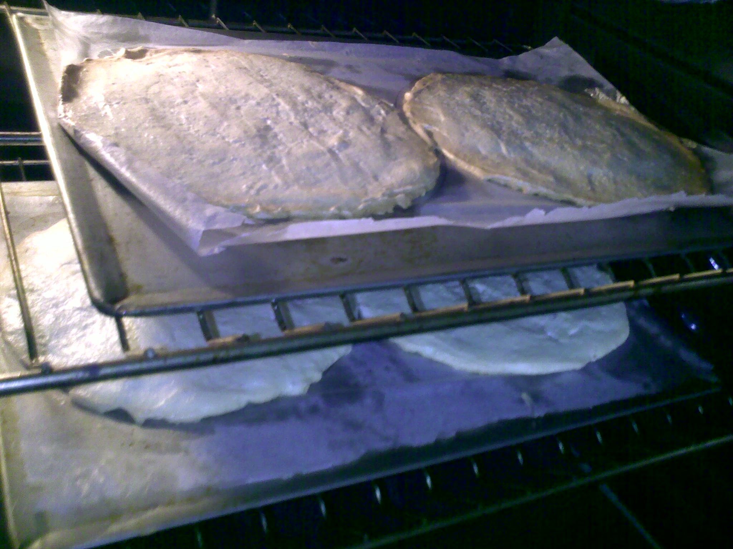

Bake for 10-12 minutes at a 320-325 F oven, turn the oven off and cool the merengues inside the oven for at least two hours. The oven should be cold to the touch, the merengue should be crispy. Watch for the oven and make sure the merengue does not burn IF YOU SPREAD THEM THINLY.
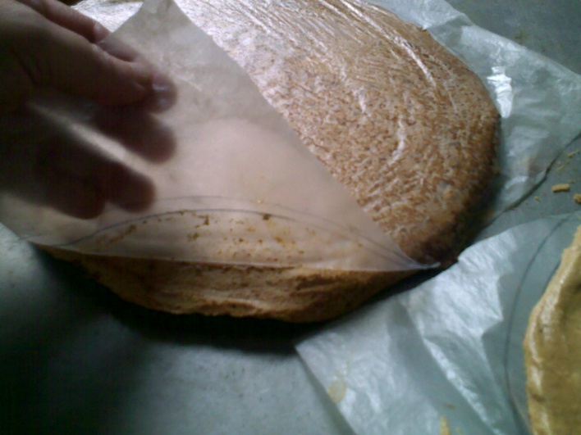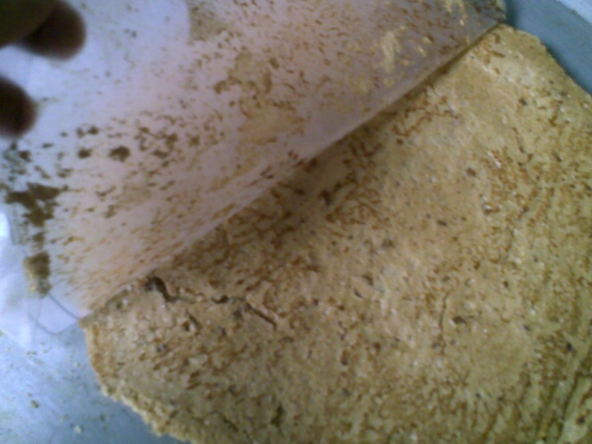
Carefully peeling off the paper from the merengue. If it breaks, don’t worry because you can patch them up during layering.
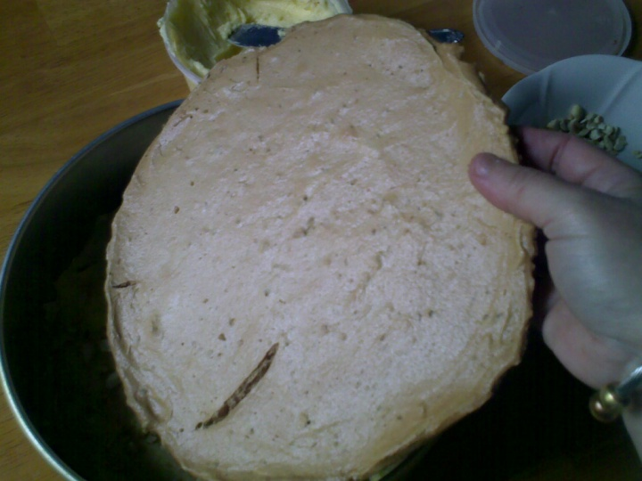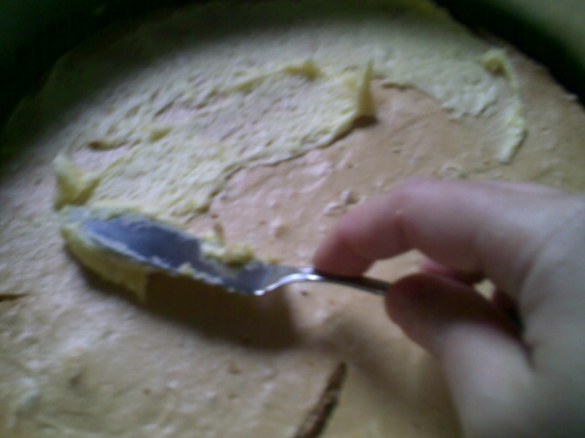
Assemble the Sans Rival by layering them first with a merengue at the bottom, buttercream, cashew nuts and so on.

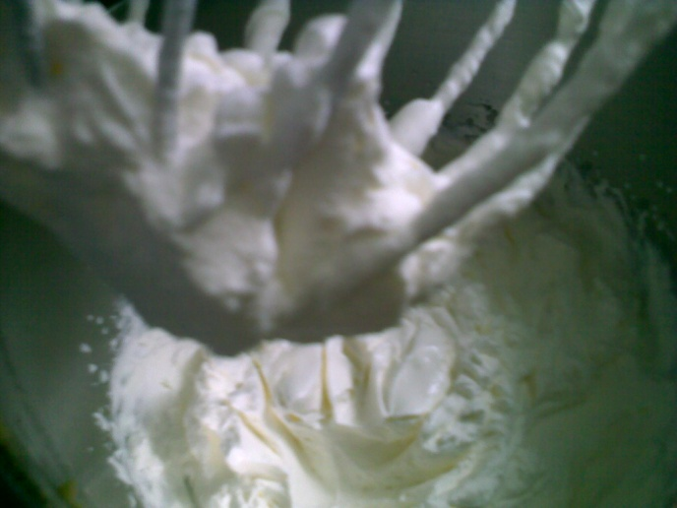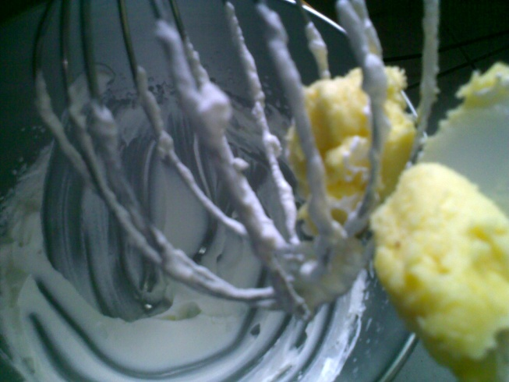
Whip the heavy cream. Remove from the mixer, then whip the buttercream.
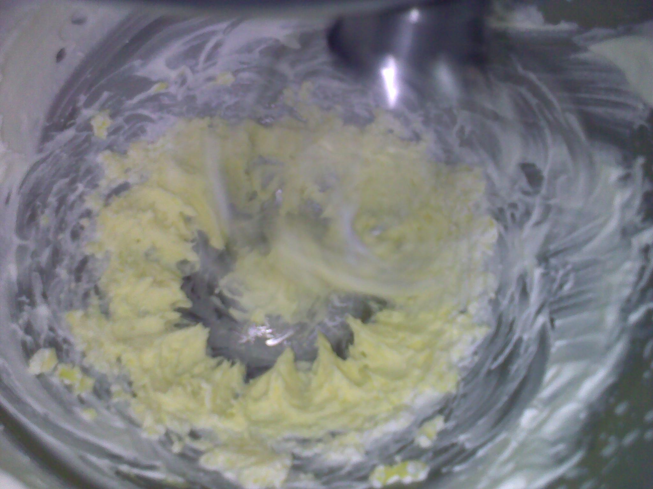
With the cream in the bowl, add the whipped cream gradually to the buttercream.
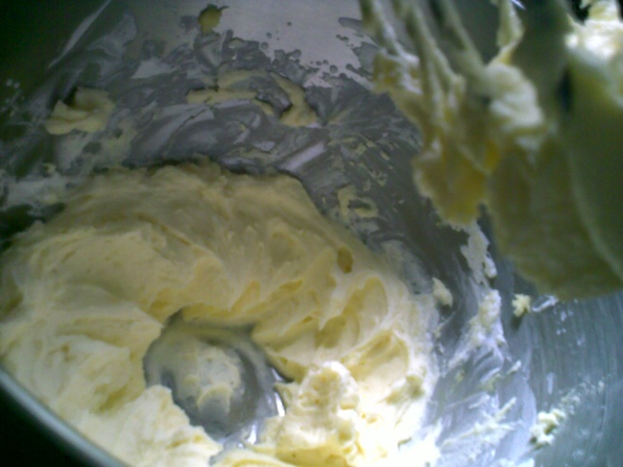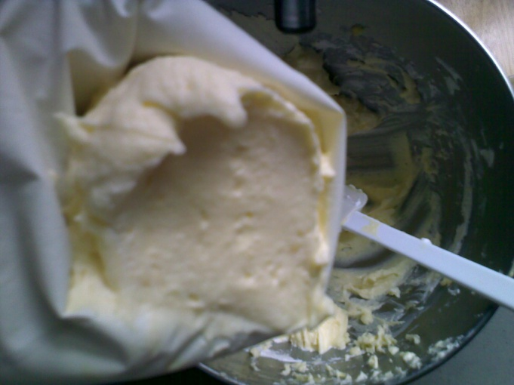
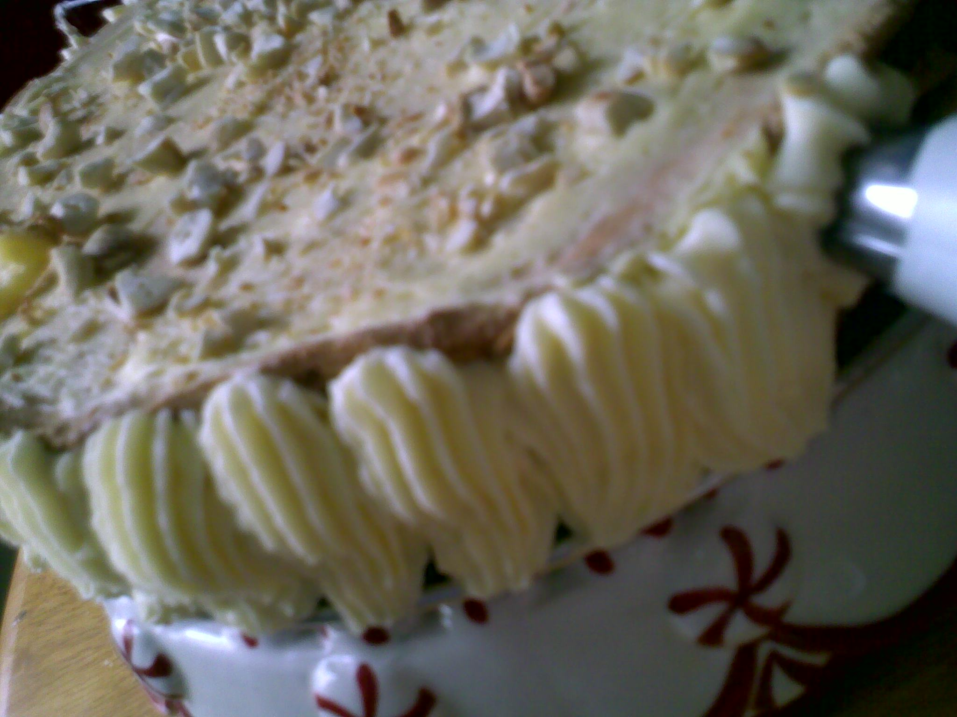
Pipe on the sides and top as desired.
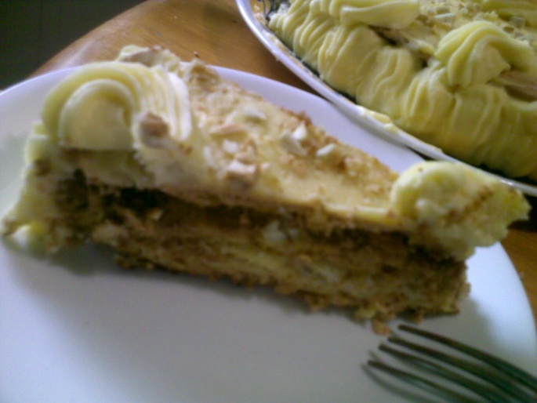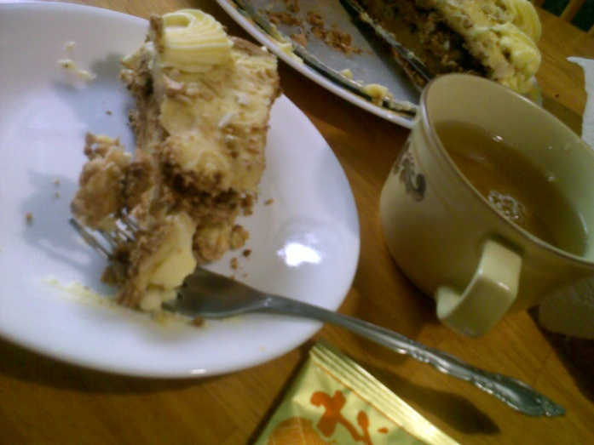
Freeze and serve cold.
BUTTERCREAM

